**Angular Forms In Depth (Angular 14) by Angular University**

Contents

Section 1: Introduction 2

Introduction to Angular Forms - why do we need a Forms module? 5

Introduction to Angular Material Form Controls 6

Section 2: Template Driven Forms In Depth 7

6. Introduction to Template Driven Forms - the ngForm Directive 7

7. Understanding how the Angular ngModel Directive Works 11

8. Introduction to Form Validation 17

9. Understanding Angular Forms CSS State Classes - ng-valid ng-dirty ng-touched 19

10. How to Display Error Messages in an Angular Form 22

11. Learn All the Built-in Template-Driven Form Validators 24

12. How to use ngSubmit - Disabling the Form Submit button 29

13. Advanced ngModel - ngModelChange and the ngModelOptions updateOn Property 33

14. Advanced ngModel - ngModelOptions In Detail 36

15. Understanding ngModel One Way and Bidirectional Data Binding 39

16. Template Driven Forms Custom Field Validator - a Password Strength Validator 44

17. How to write a Custom Form Field Validator Function 45

18. Implementing a Custom Form Field Validation Directive 45

19. Multiple error messages per form field - Understanding the problem 49

20. The onlyOneError Custom Pipe - API Design 51

21. The onlyOneError Custom Pipe - Step-by-Step Implementation 52

Section 3: Introduction to Angular Reactive Forms 56

22. Introduction to Angular Reactive Forms 56

23. Introduction to Reactive Forms - Step-by-Step Example 56

24. Reactive Forms - The Form Control Directive and Custom Validators 56

25. The Form Builder API - Writing much more concise Reactive Forms 56

26. Comparing Reactive and Template Driven Forms 56

27. Angular Strictly Typed Forms 56

28. Non Nullable Form Builder 56

Section 4: Angular Reactive Forms In Depth 57

29. New Section - Advanced Reactive Forms 57

30. Building an Angular Multi-Step Reactive Form with Angular Material 57

31. Angular Asynchronous Form Validators 57

32. Angular Forms Controls - How to add a DatePicker field to a Reactive Form 57

33. Angular Form Controls - Checkbox and Text Area 57

34. Angular Selection Dropdown Form Control - Step-by-Step Example 57

35. Multi-Step Forms - Displaying an Error Message per Step 57

36. Reactive Forms - Dynamically Enabling and Disabling Form Fields 57

37. Angular Material Date Range Selector - Step-by-Step Example 57

38. Reactive Forms Multi-field Custom Validation 57

39. How to implement Form Draft Pre-Save using the valueChanges Observable API 57

Section 5: Angular Custom Form Controls 58

40. New Section - Angular Custom Form Controls - a File Upload Component 58

41. Custom File Upload Component - Step-by-Step Implementation 58

42. Angular File Upload - Opening a File Upload Dialog 58

43. Angular File Upload - Uploading to a Node Server using the HTTP Client 58

44. Implementing a File Upload Progress Indicator 58

45. Understanding the Angular Forms ControlValueAccessor Interface 58

46. ControlValueAccessor Interface - Step-by-Step Implementation 58

47. ControlValueAccessor - Setting Up DI Configuration and Demo 58

48. Angular Custom Form Controls - The Validator Interface 58

49. What is a Reusable Nested Form? 59

50. How to Use ControlValueAccessor to implement a Nested Form 59

Section 6: Form Arrays In Depth 59

51. New Section - Setting Up Step 3 of our Multi-step Form 59

52. Preparing Step 3 of our Multi-Step Form 59

53. Angular Form Arrays - Step-by-Step Example 59

54. Angular Multi-Step Form - Final Demo 59

Section 7: Conclusion 59

55. Bonus Lecture 59

56. Angular Forms In Depth - Conclusions & Key Takeaways 59

# Section 1: Introduction

Angular allows us to build forms in a scalable and user-friendly way using the angular

forms module.

The angular forms module provides us with two alternative ways of building forms, **template driven forms** and **reactive forms**.

Source Code in GitHub:

<https://github.com/angular-university/angular-forms-course>

<https://github.com/angular-university/angular-forms-course/tree/1-start>

IDE:



After downloading the source code, run “npm start” and not “ng serve”, as it has the required configuration as shown below:

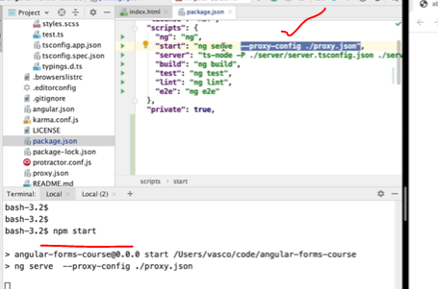

For backend, start in a new terminal “npm run server”

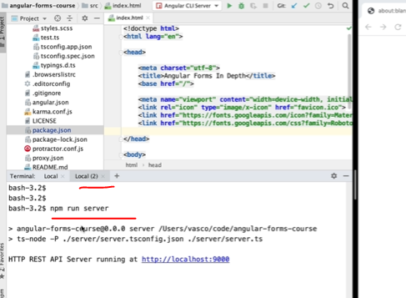

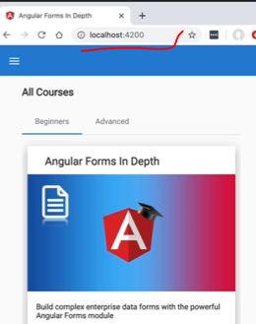

We are going to start with template driven forms, **which are recommended for simpler forms**, for example, with **just a couple of fields and not a lot of validation rules**.

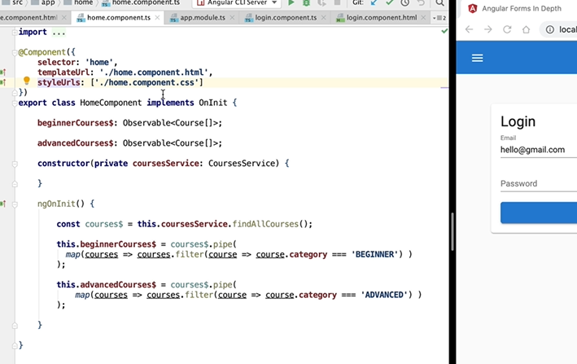

## Introduction to Angular Forms - why do we need a Forms module?

Angular is a web framework.

Angular is all about the notion of components and the separation between data and views.

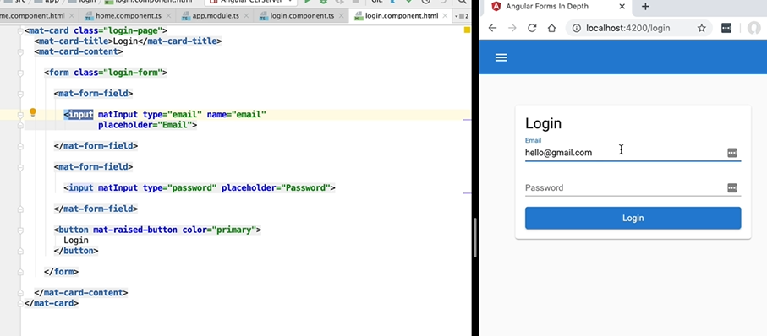

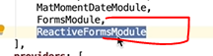

The **forms module** adds to our application the capability of doing **template driven forms**.

**Reactive forms** that are enabled by importing the **reactive forms module**.

In general, **you don't have to import both in a single application**.

You only need to import the forms module that you need.

**Both modules provide identical functionality**, the ability of doing data binding to a form, automatically retrieving, or setting the data of the form.

And both modules also provide ways of validating the form.

It's important to understand that these two modules provide identical functionality and they are alternative to each other.

## Introduction to Angular Material Form Controls

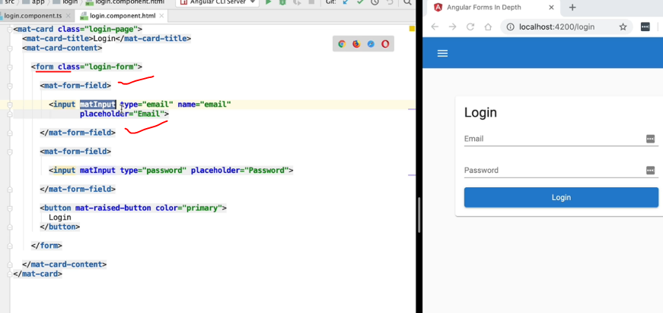

If we don’t like floating fields:

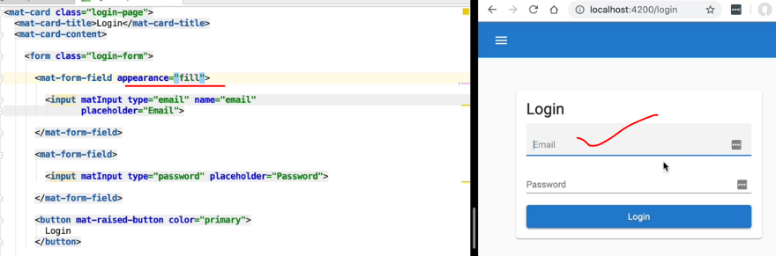

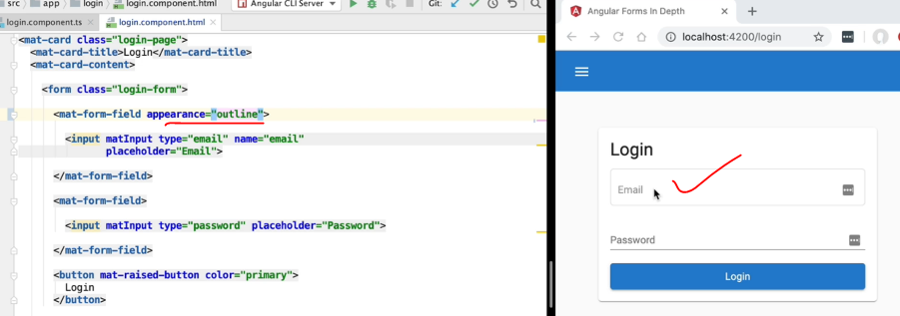

# Section 2: Template Driven Forms In Depth

## 6. Introduction to Template Driven Forms - the ngForm Directive

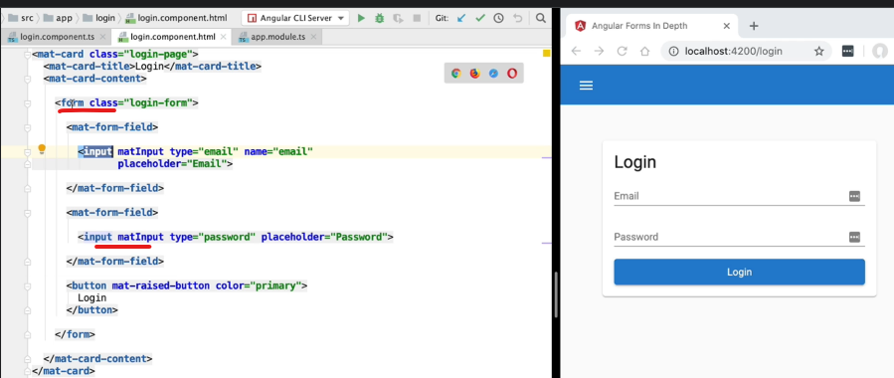

We need to do 2 things here:

* Get the data that user has provided
* Validate the data provided

In template driven forms all these including validations will be done in the template (HTML) file itself and we don’t have to do anything in the Component (.ts) file. **That is why it is called as “template driven forms”.**

For this we have to import the “FormsModule” in the imports array of the app.module.ts file.

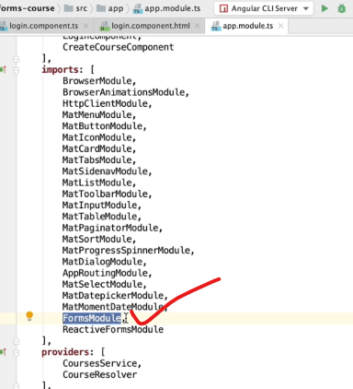

**Note**: By importing the FormsModule, Angular will apply a directive called as ngForm to all the form tags implicitly, even if we have not mentioned it.

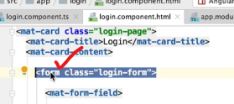

1 of the features of the ngForm directive is that it has exported it self.

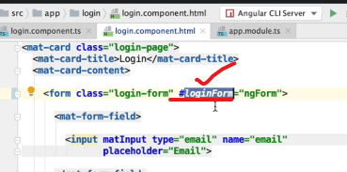

Here #loginForm is the “local template variable”. As the ngForm directive was exported, here we can assign it to the local template variable.

Now what all can we do with this ngForm reference:

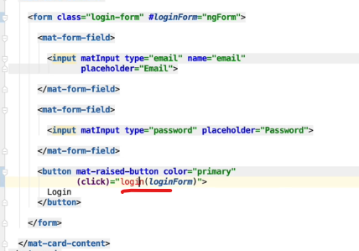

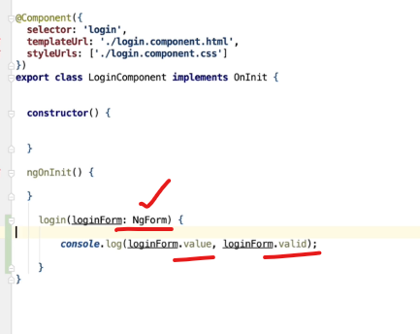

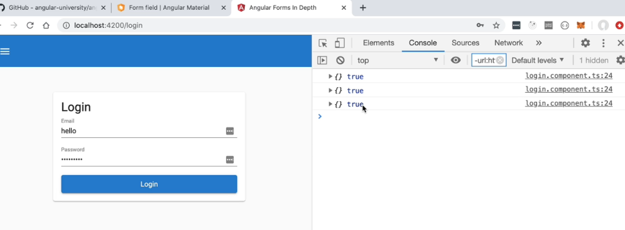

Without giving anything also if we click login button, it will print empty as we have not yet linked the form with the form field controls.

Also, it is valid every time as we have not yet done the validations part.

## 7. Understanding how the Angular ngModel Directive Works

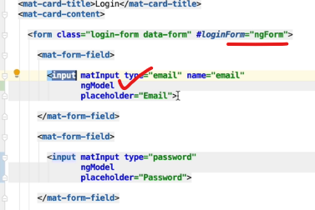

The ngModel directive **binds the fields with the ngForm directive**. Without it, Angular will not get the field values. Also, without it Angular will not be able to validate the value.

Error:

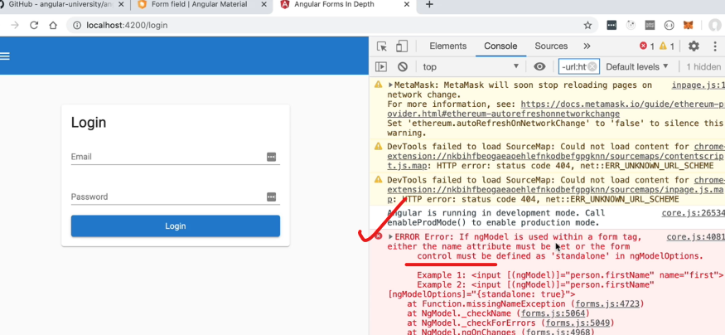

This error is coming as the password field does not have a name attribute:

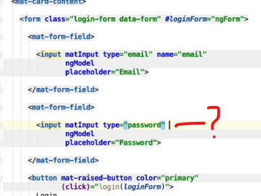

Solution: Add the name attribute

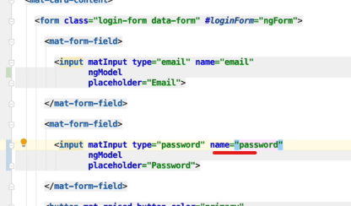

Error Solved!

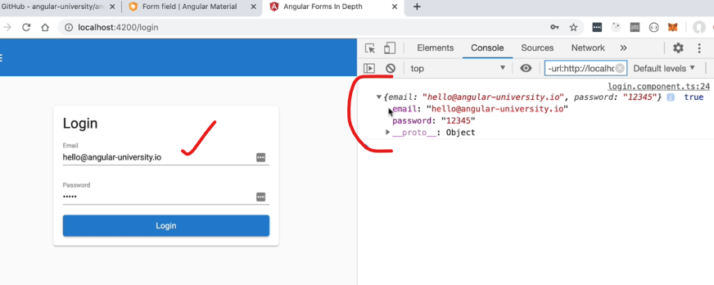

Now we are able to get the values, after adding the ngModel directive.

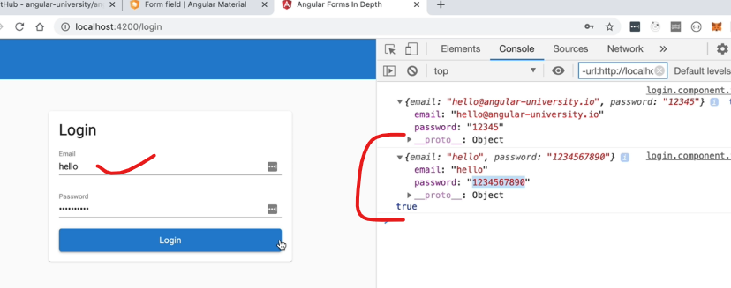

Also if we modify the data, we are able to get the modified data in the console.

But how?

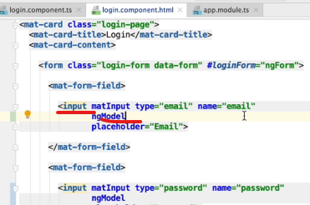

ngModel binds with the input tag and it tracks any events applied to the input, for example, key-up, key-down, etc.

After each of those events ngModel will gather the value of the input. This will happen after every Angular change detection cycle.

To see this in action:

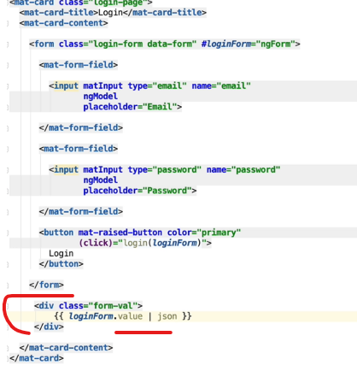

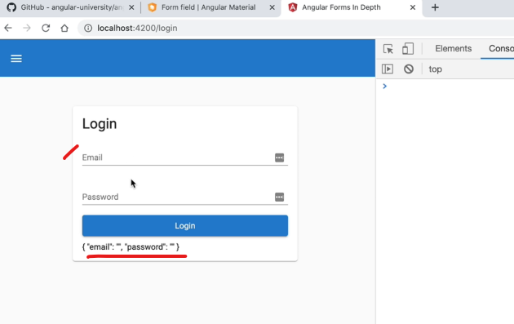

On page load, we get the initial values of the fields.

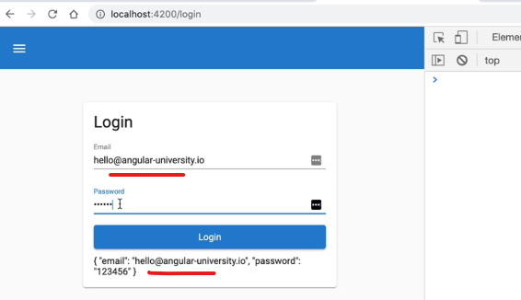

So as we can see, as we type, the value of the form is getting immediately updated with each keystroke.

So this means that the engie model they're active in each of the controls is binding to the control

and these registering event listeners for important events such as the key-up event in order to track

the value of the form fields.

The engie form directive applied to the forum is then going to access each of the individual engy model

directives, and from there it's going to build a full value object corresponding to the complete value

of the forum.

ngModel tracks.

The value of each input control via event handlers and ngForm is going to access the ngModel applied to each of the controls and from there build a complete FormValue Object.

To prove that it is ngModel is the one responsible for tacking and updating the form field values, lets create a template variable and put ngModel in it, in the similar fashion like we did for the ngForm.

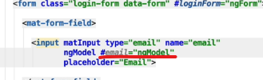

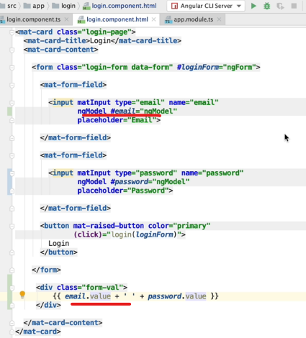

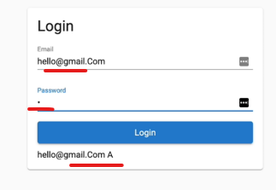

This proves that it is indeed the ngModel directive that is tracking each form field.

ngForm will interact with each of the ngModel directives in order to retrieve the value of the corresponding field and also its validity state. So this is how ngForm knows the values and the validity state of all the fields in the form.

## 8. Introduction to Form Validation

Abc

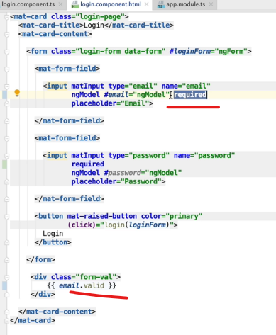

If any one of the child controls are invalid, the whole form becomes invalid.

The form will become valid only when all the child controls are valid.

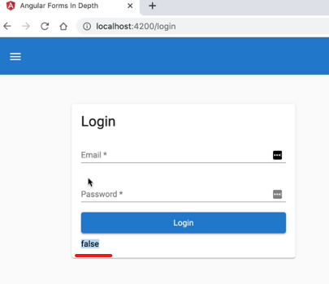

Initially it is false.

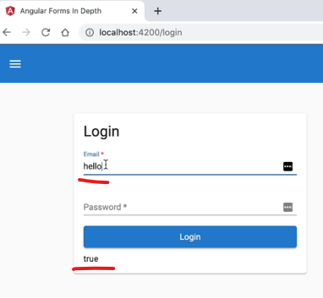

As soon as we type something it becomes valid.

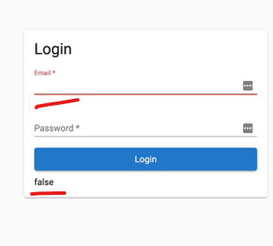

If we delete it, again the validity state becomes as false.

But then how come, the filed is also becoming red color? Lets see that in the next lesson.

## 9. Understanding Angular Forms CSS State Classes - ng-valid ng-dirty ng-touched

The red colour is appended by the **ngModel**. Based on the validity state of the field based on the field value, the ngModel adds/deletes the CSS classes from the fields.

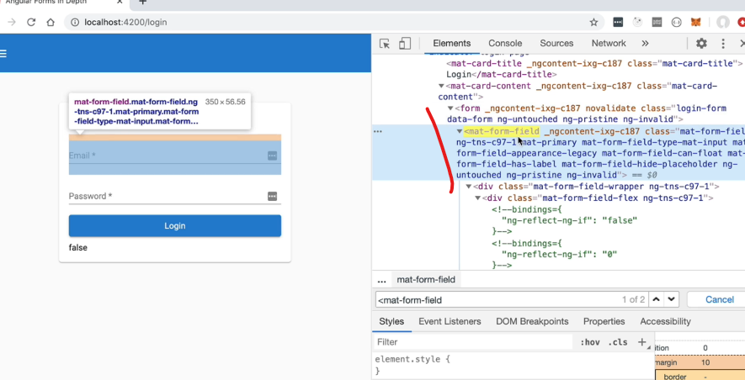

On page load only Angular adds a few State class to the fields with the prefix of “ng-”

ng-untouched

ng-pristine

ng-invalid

Imp **Note**:

Each form control has 3 separate states:

State 1: touched or untouched

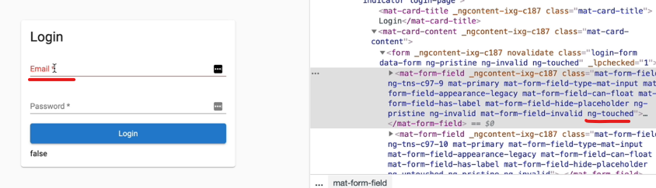

Note: it does not becomes touched as soon as you click on the form field. It becomes touched when we click somewhere else outside after clicking on the field.

State 2: valid or invalid

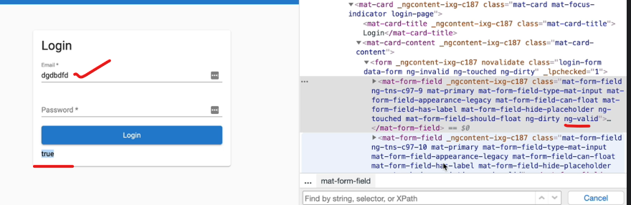

State 3: pristine or dirty

If dirty means it is not in sync with our persistence layer at the backend... and user has done some modifications on the filed which might need a save to the database.

Add custom styles based on states of the field:

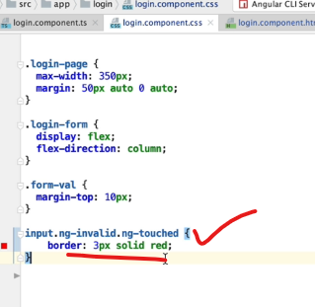

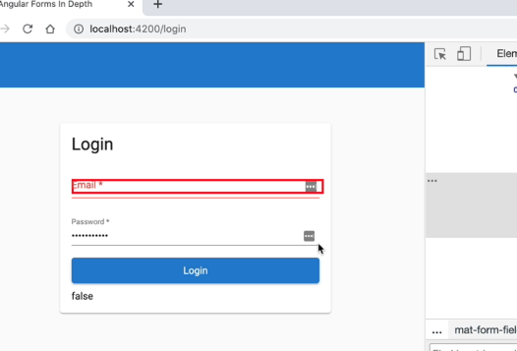

It will only show error, when invalid and touched by user.

What about the form as a whole?

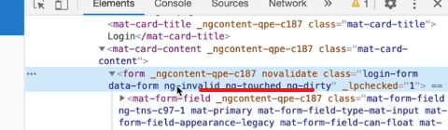

The form reflects the state of its fields.

If any one of the fields is touched, then the form becomes touched.

If any one of the fields becomes dirty, then the form becomes dirty.

The form will only be valid, if all the fields in the form is valid.

## 10. How to Display Error Messages in an Angular Form

As we know, the ngModel also tracks the validity state of the field.

The same ngModel object will produce an errors object detailing all the errors currently present in the form field.

Let’s see the errors object:

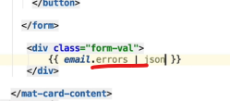

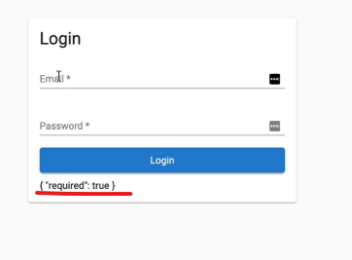

If we start filling the field the errors object becomes null: means there are no errors related to the Email field.

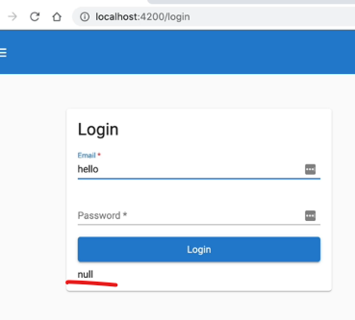

Now let’s use this error object to show errors to the user:

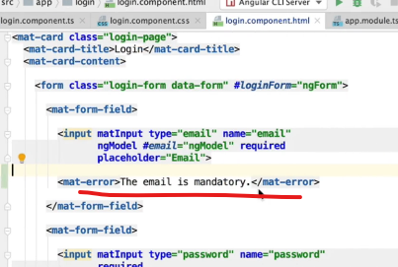

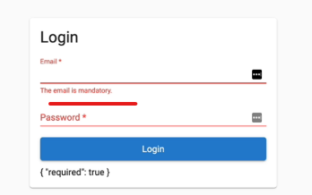

But what if we have multiple errors:

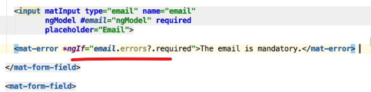

Note: don’t forget the elvis operator (?) as email.errors can be null as well.

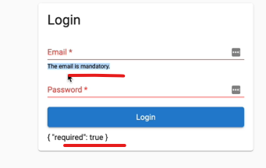

As we can observe we have only 1 error placeholder per filed, we will see later how to show only 1 error msg at a time.

For now lets see what all in built form validators are present.

## 11. Learn All the Built-in Template-Driven Form Validators

Let’s add 1 more validation

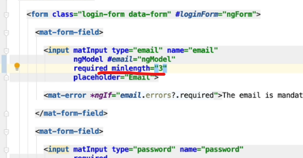

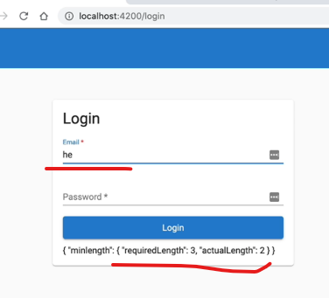

Here in the error object, there is a minlength added.

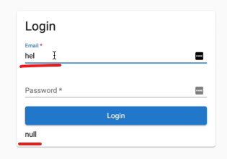

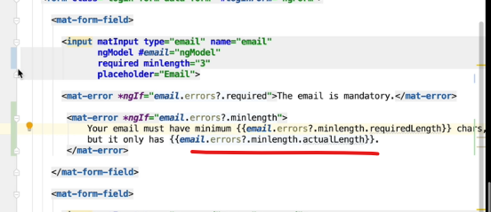

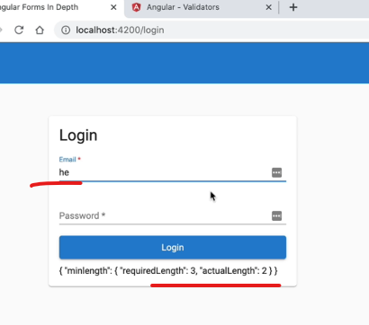

As soon as you type, and it is invalid, the error message does not show up… it is a good thing as then the user will not be distracted.

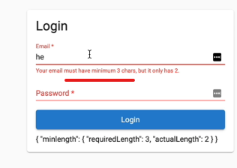

As soon as we go away from the field, then only the error will show up.

Note:

As we add the FormsModule, then Angular adds this “novalidate” attribute in the form tags is added to disable the default HTML5 validations.

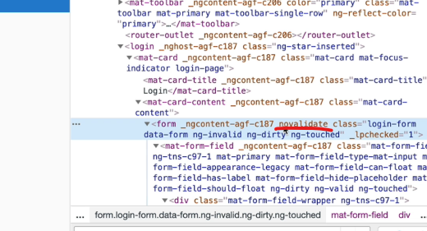

For maxlength, user will not be able to type in the field after the defined characters.

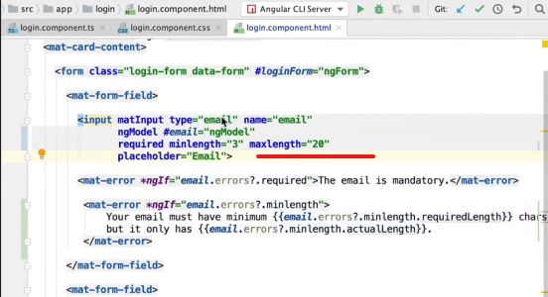

Email validator:

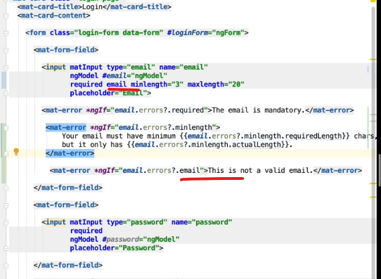

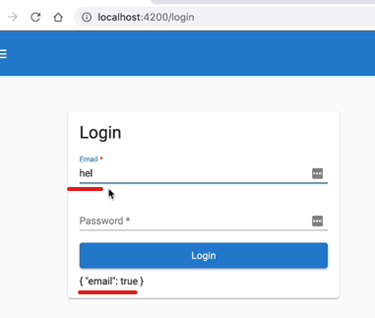

Pattern validator:

Compare Against as JavaScript RegEx pattern

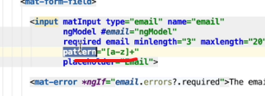

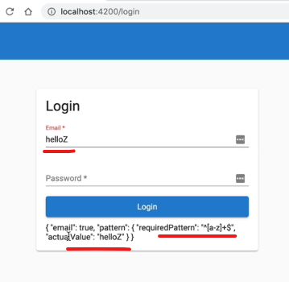

These are all the inbuilt validators for template driven forms.

Note: These are only client side validators, we should also have these same rules applied in our backend systems for security reasons.

Note: Frontend validations is only for user experience. To help the user to fill valid data in the form. This is not done for security reasons in the frontend.

## 12. How to use ngSubmit - Disabling the Form Submit button

This is a typical HTML form submit button:

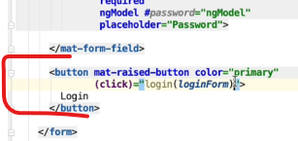

If we just make it as type submit:

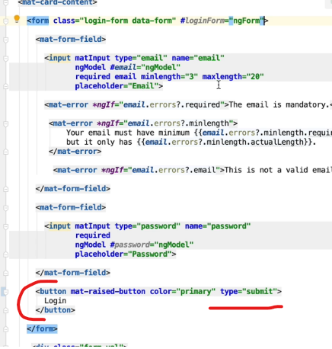

Then the default behaviour of HTML is to submit the form and do a HTTP post request to the backend and then replace the current page with the page returned in the POST response.

But this is not what we want in a SPA. Also, every time we may not want a POST method.

So we will use Angular ngSubmit:

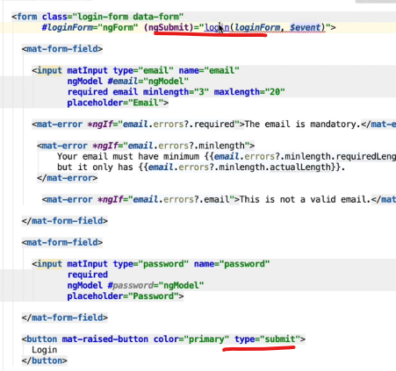

ngSubmit will prevent the default HTML behaviour.

ngSubmit will help us to access the native form submit event if we need it.

$event = native HTML Submit event

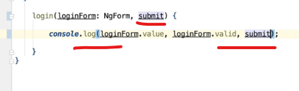

If we want to disable the button till the form is valid:

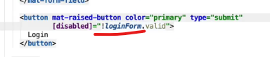

On page load the button is disabled as expected:

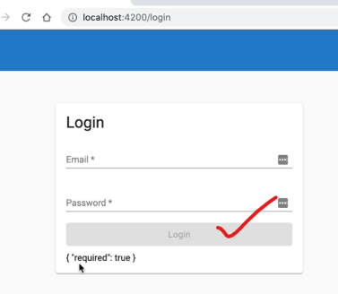

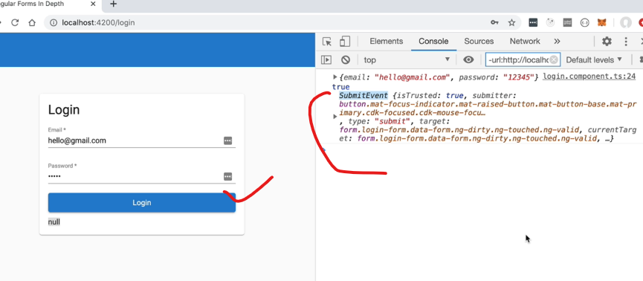

We also get the native submit event.

Note: For template driven forms, if we don’t want to use the ngSubmit, then we can also use the (click) event as we were using it earlier.

Note: The only difference between the 2 is that we get access to $event in case of ngSubmit, in case you need it for some use case.

## 13. Advanced ngModel - ngModelChange and the ngModelOptions updateOn Property

ngModelChange event is an event emitted by any field which the ngModel is applied to.

If we want to subscribe to any change in the model, then we can use ngModelChange:

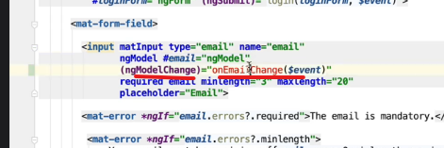

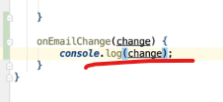

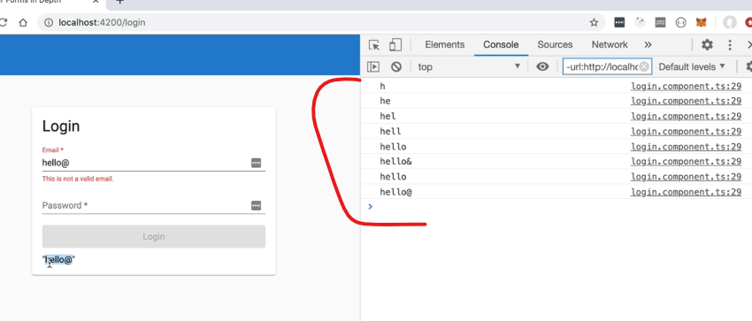

Next for example, we want to check if the email user provided is already available in the Db, and the user must enter a new email. In this case using ngModelChange is not recommended as for each change there will be a backend call. So we need a event when user has finished typing in and moves away from that field.

We can use ngModelOptions property, it is an input property of the ngModel directive applied here to to this form. This will take in a JS configuration object.

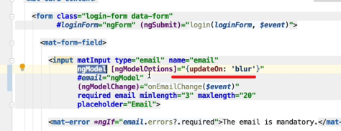

With this the ngModel will only emit a change event only on blur.

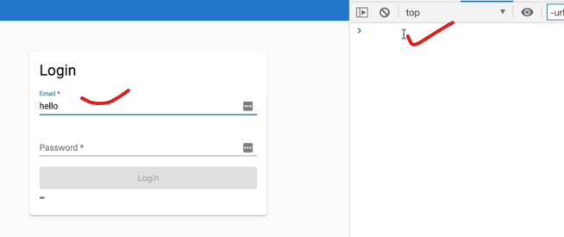

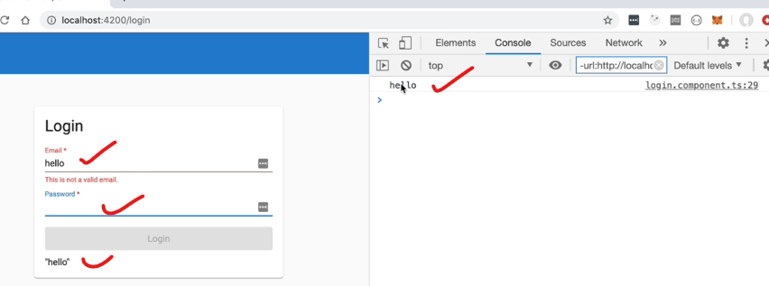

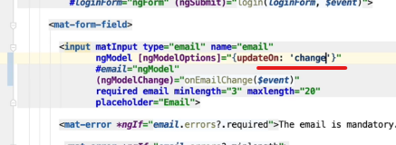

Emit event each time the value changes.

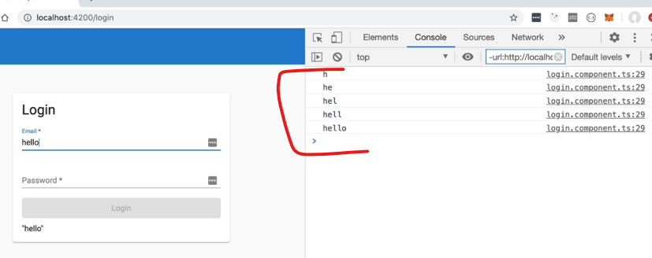

This is the default behaviour. For this we don’t have to use the ngModelOptions.

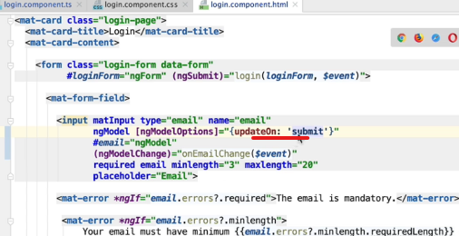

The value of this email filed is going to be set only when we submit the whole form.

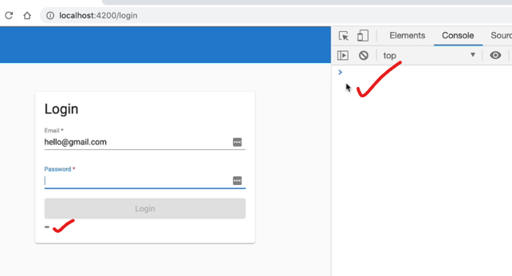

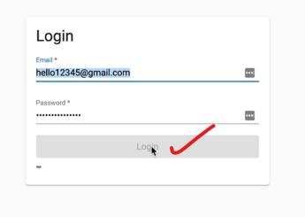

The button is disabled, which is expected as the model value will only be set on submit.

## 14. Advanced ngModel - ngModelOptions In Detail

If in some scenario, we are unable to use the name attribute in our input tag, then we can do so in ngModelOptions:

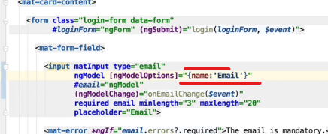

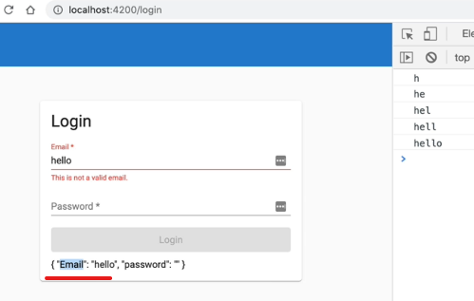

Email with capital E is registered.

Standalone property: it helps any form control in general, to be in standalone mode, disconnected from the parent ngForm.

Means the ngForm will not be able to get/ nor be aware of the values of this field.

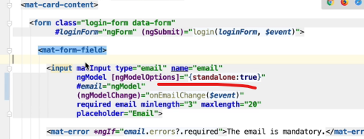

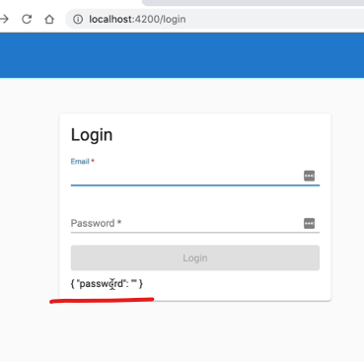

Email is no longer part of the form.

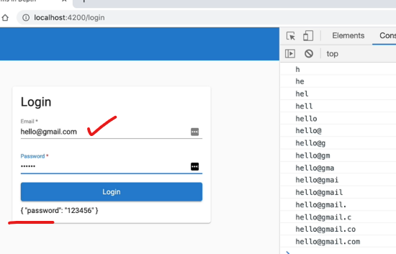

The ngForm is not getting the values from the model anymore.

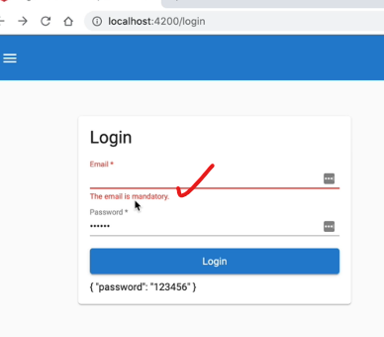

The validations will work, the only thing is the parent form will not be notified.

Use case for this can be some, search box in the form which we don’t want to be included in the parent form. The default value for this is false.

## 15. Understanding ngModel One Way and Bidirectional Data Binding

Now what if we want to set some initial value in the form:

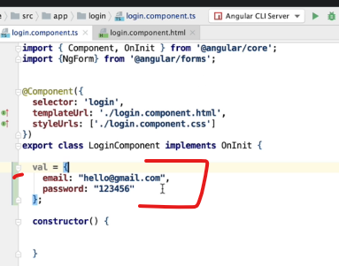

[ngModel]: Angular Input Template Syntax (the square bracket syntax)

This syntax is used to write a value to the input.

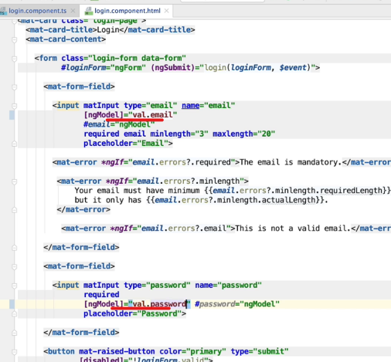

On page load it is working as expected: (prefilled as expected)

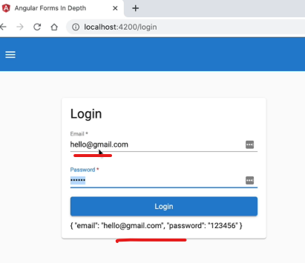

But if we change the values here, will it reflect in the val object that we defined earlier:

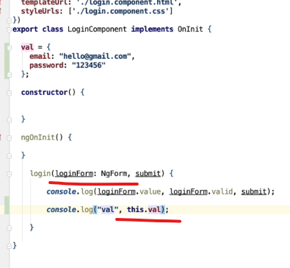

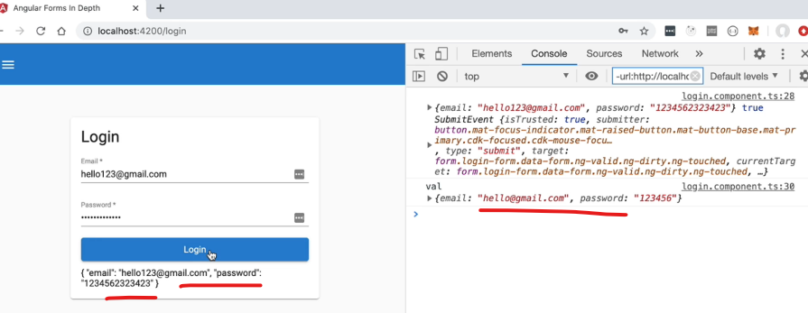

We do not get the updated values in the log.

This is unidirectional flow of data.

Now let’s see bidirectional data binding

From component to the template and also from the template to the component.

[(ngModel)]

Here we are doing Both for assigning a property and subscribing to the events.

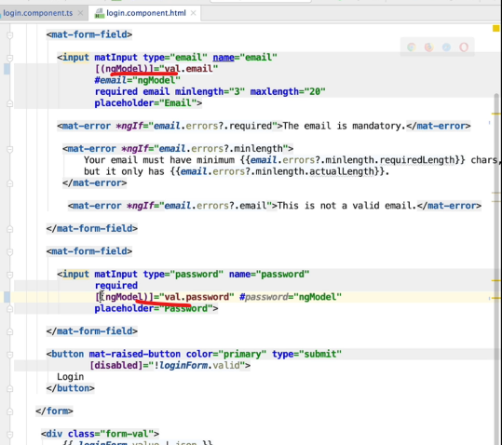

Also, sometimes can be remembered as “box of bananas” syntax. 😊

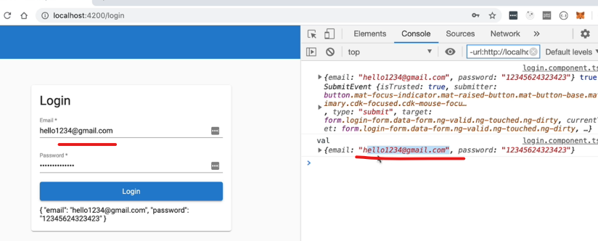

Now we get the latest data of the form.

## 16. Template Driven Forms Custom Field Validator - a Password Strength Validator

Now we will create a custom directive for password strength validator.

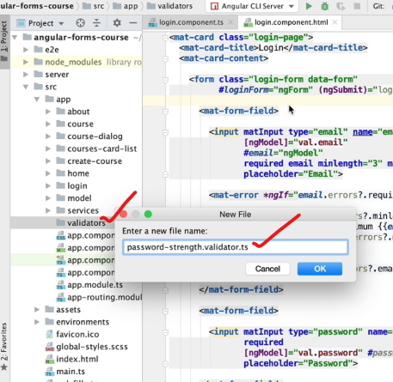

Create a new folder and a new file inside it.

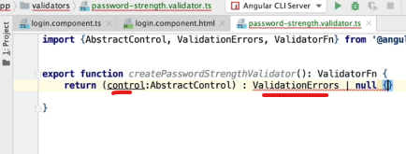

Take input as the control itself. And return a series of ValidationErrors or null if there are no errors.

## 17. How to write a Custom Form Field Validator Function

Let’s work on the body of our custom validator.

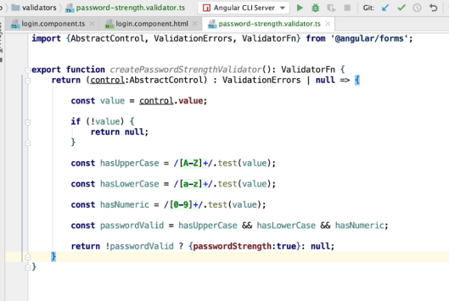

This has only to be done for template driven forms. For reactive forms we will be able to use this function directly, will see later.

## 18. Implementing a Custom Form Field Validation Directive

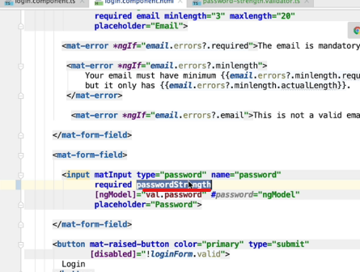

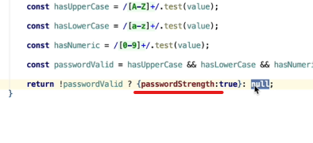

Now we will implement our custom validation directive.

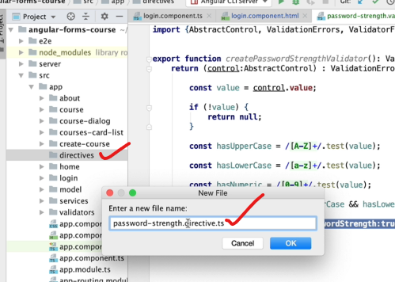

Create a new folder and a file.

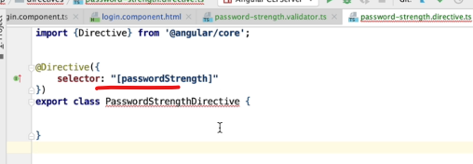

If this attribute is found in the form control, then only this directive will be instantiated. Square brackets are the attribute selector syntax.

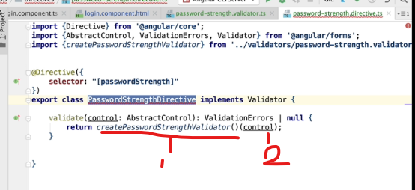

This has the same syntax as for the pass strength validator class.

1: Called to create the validation function

2: Then call the validation function with the input with the control to get the validation result.

With this the implementation is done for the password strength directive.

Now, we have to register it in our application.

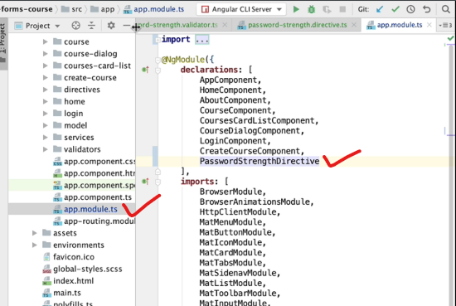

The above will still not work as we forgot 1 thing:

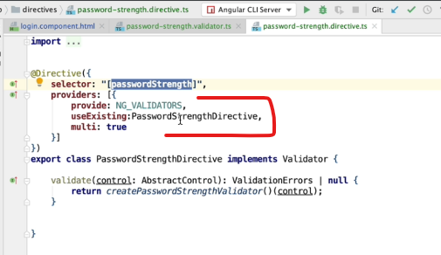

We have to inform Angular that this is not a normal angular directive. But this is specifically a form field validation directive. And we do that via the Angular dependency injection system.

So in the “providers” property of our directive, we have to register this directive as a form field validation directive. We do so by adding this directive to the list of directives that the Angular framework already knows that are meant for doing form validations.

Our class is just one of the many validations that Angular provide via the NG_VALIDATORS provider. So, we do not want to override it with our class, rather want to add to that list.

Multi:true, will allow multiple values for the provider, so by this way our class will be added to that list.

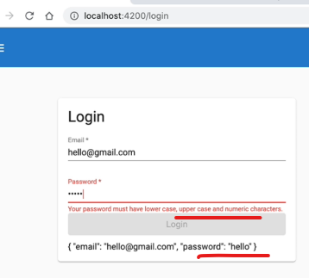

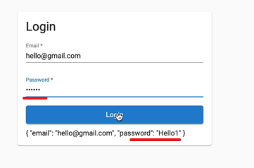

## 19. Multiple error messages per form field - Understanding the problem

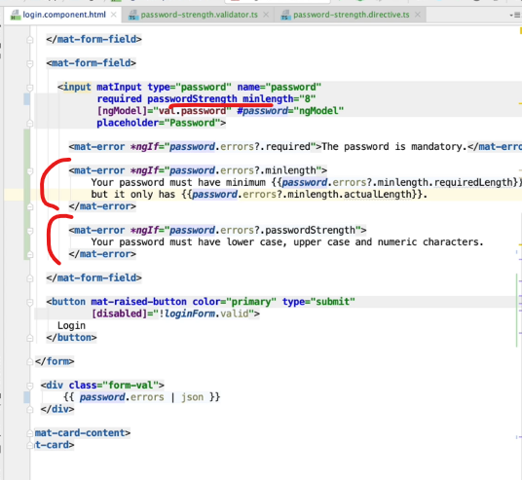

Here both minlength and passwordStrength can show error together, which we may not want.

Initial on page load:

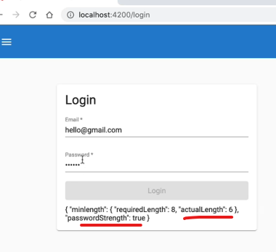

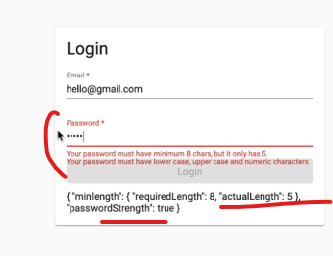

Now both the errors show up. 2 active errors for the same field. It is not a good user experience. The user may get confused.

## 20. The onlyOneError Custom Pipe - API Design

Instead of having to show multiple errors to the user, we have to tell Angular the priority of the errors to show one by one.

We can do this with a custom Angular pipe.

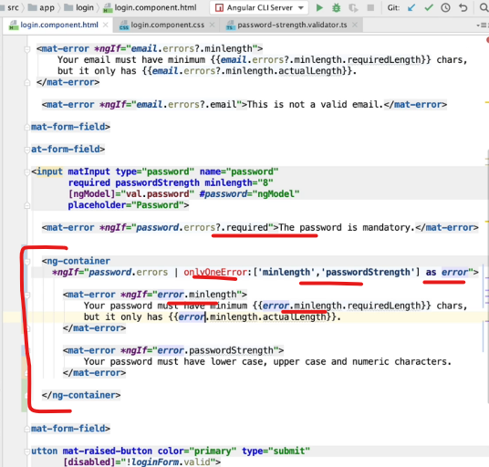

ng-container will not create an extra div in the DOM.

We will pass our priority of errors in the array.

In the next lesson let’s implement this custom pipe onlyOneerror.

## 21. The onlyOneError Custom Pipe - Step-by-Step Implementation

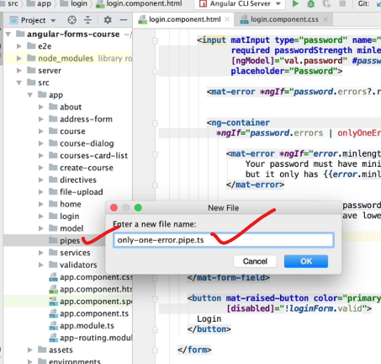

Create a new folder and a file inside it.

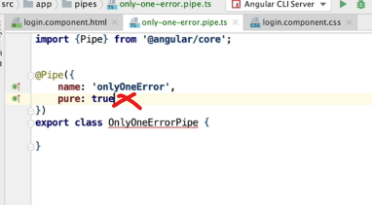

Name: the name that we will use in the template.

Pure:true is not required.

Note: **Angular pipes by default are pure.**

Pure pipe means that the pipe is only going to recompute its output if its input changes.

Angular impure pipe will compute its output with each Angular change detection run.

Declare our custom pipe here:

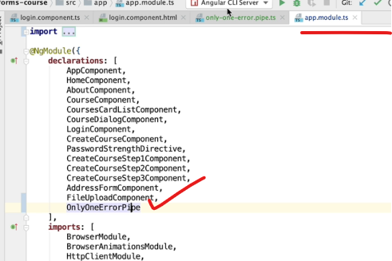

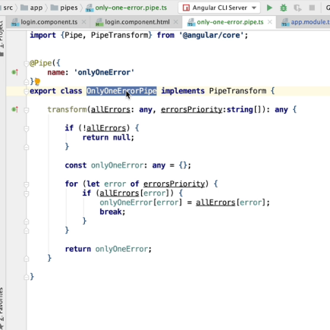

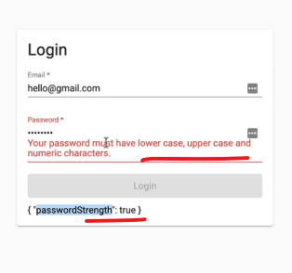

It only has a CSS issue

We need to move the container outside mat-form-field as it does content projection and it will not work with ng-container.

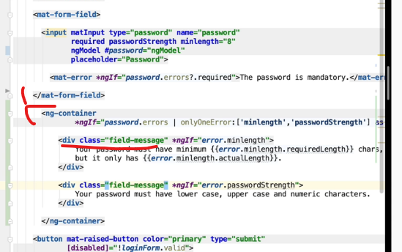

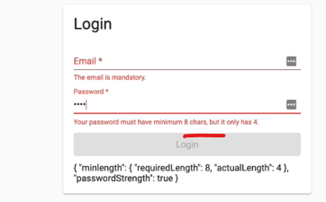

Note 1:

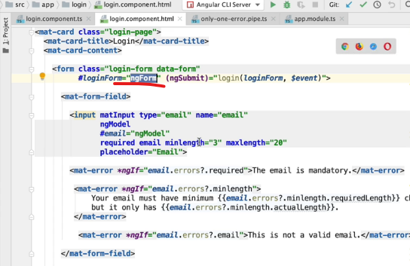

ngForm is very specific to only template driven forms

here everything happens at the level of the template, that’s why it is called as template driven forms.

They are good for simple forms and do not scale well.

Just for 2 fields just look at the number of directives we have to use.

Template should be how we define our View and nothing more.

Here we are also applying the logic for our components, which should ideally have been in the component class and not of the template.

Also, we cannot use this type of forms for complex business validations.

This is only for apps where a simple form is required with just a few fields and for rest all cases we need to use Reactive forms.

# Section 3: Introduction to Angular Reactive Forms

## 22. Introduction to Angular Reactive Forms

With reactive forms, we define the model of our form programmatically at the level of the component class. And not at the level of the template.

The template is kept only for the view of the form and not its business validation rules.

They are called reactive forms because they expose on its APIs certain Observables that make it very simple to implement certain use cases.

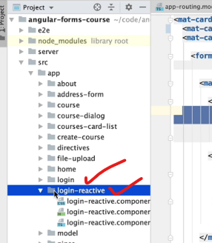

We will not touch the template driven form folder “login”.

Rather use a new folder “login-reactive”.

The initial code:

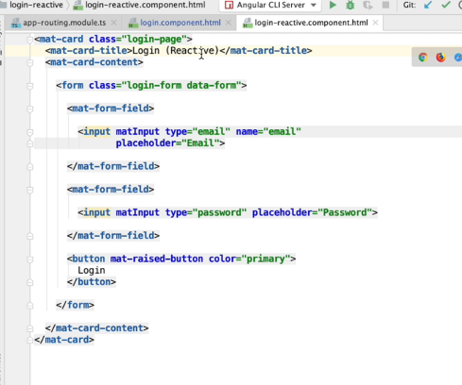

Lets change the routing as well:

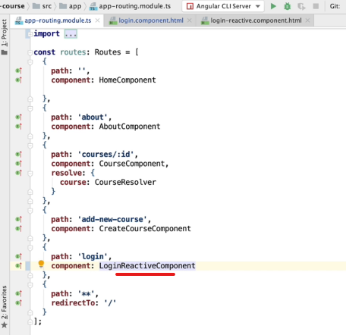

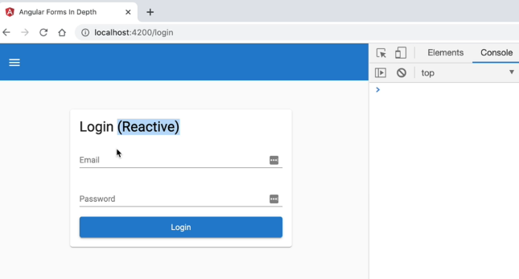

## 23. Introduction to Reactive Forms - Step-by-Step Example

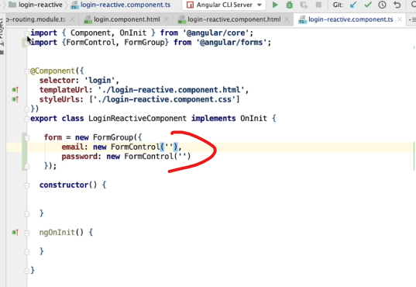

Let’s do some basic validations:

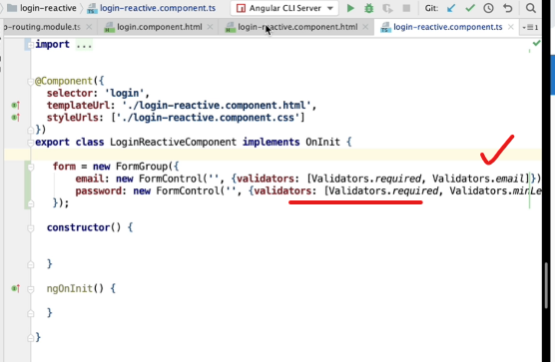

Next, we have to just link it:

We have to use a new directive from Reactive forms, [formsGroup]

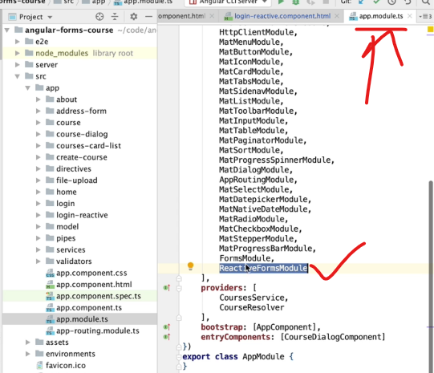

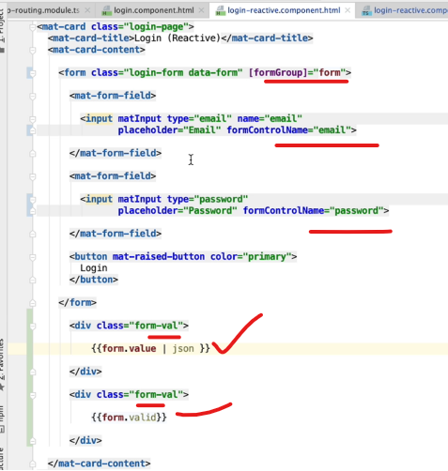

The template remains very clean in this case.

Initial page load:

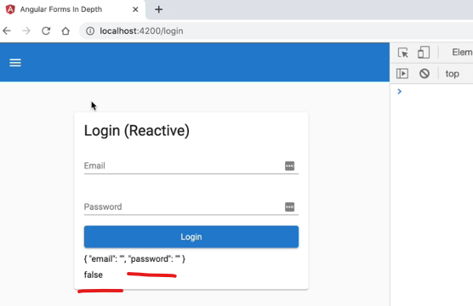

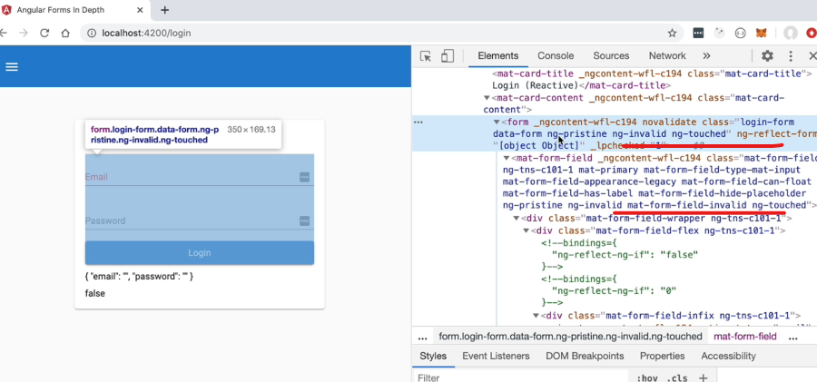

We can observe the same CSS classes are being applied to the form and the form-field as well.

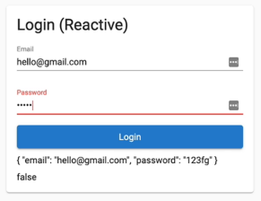

## 24. Reactive Forms - The Form Control Directive and Custom Validators

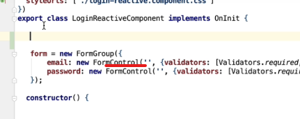

We can create these formControls in any way programmatically we want. Even outside of the FormGroup.

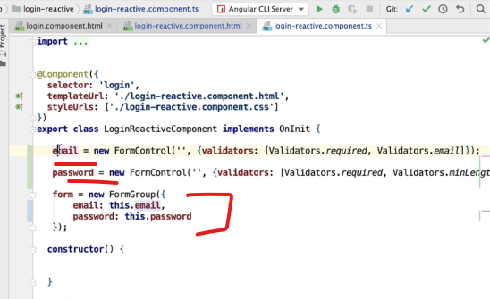

Now in html, we can directly use it with [formControl]:

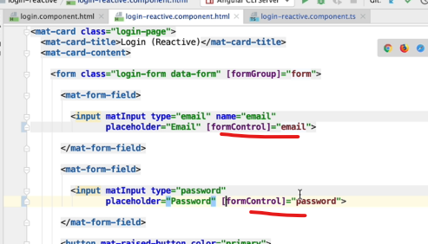

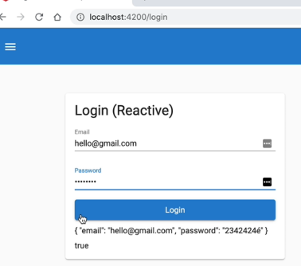

Next let’s work to validate the email only on blur. (here later we can do a backend call to check if the email already exists)

And also work on password strength validator.

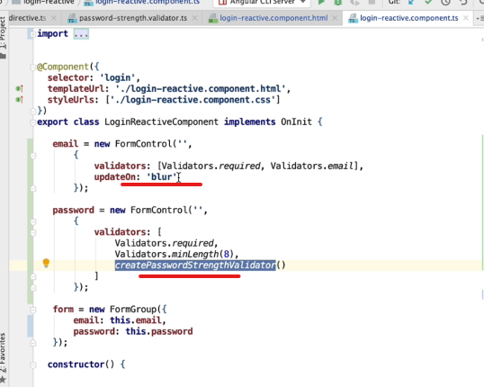

For createPasswordStrenth, this time we don’t have to create any custom directives.

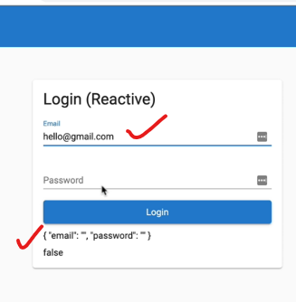

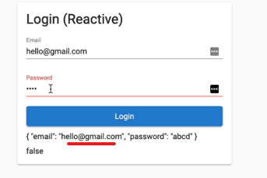

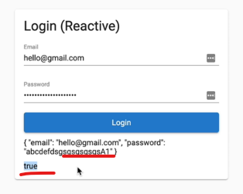

## 25. The Form Builder API - Writing much more concise Reactive Forms

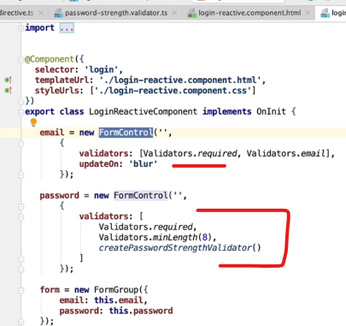

Sometimes creating form this way can become verbose.

So, lets simplify it further using an Angular service called as FormBuilder.

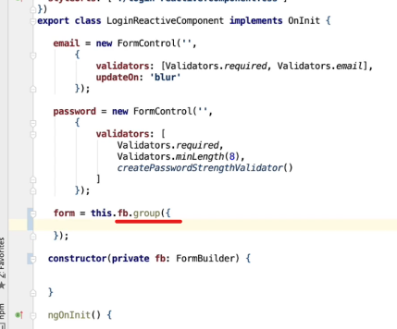

We can directly call the “group” API of the FormBuilder service.

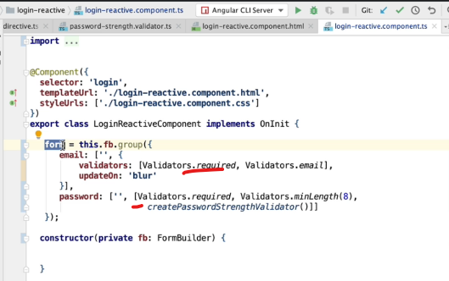

For email, as we need to update it only on blur, instead of sending an array of validators in the 2nd parameter, we need to send a configuration object.

The 1st parameter is the initial value of the form field.

In the template we have to use:

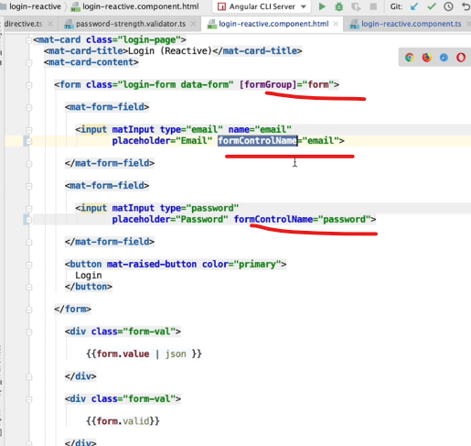

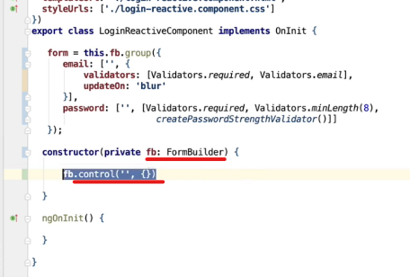

We can also create individual form controls, but it is not required.

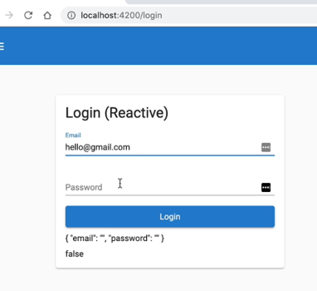

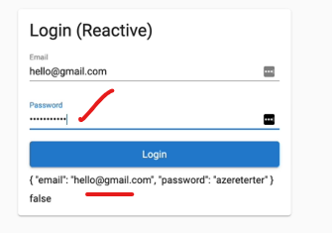

Now our form is lot more concise.

## 26. Comparing Reactive and Template Driven Forms

Abc

Now to access the form control for showing errors:

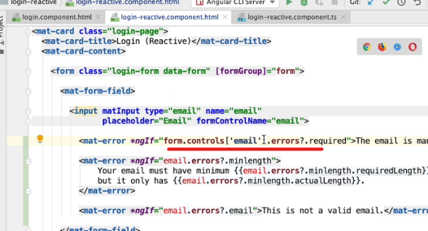

It is a bit verbose, so let’s define filed in the component class.

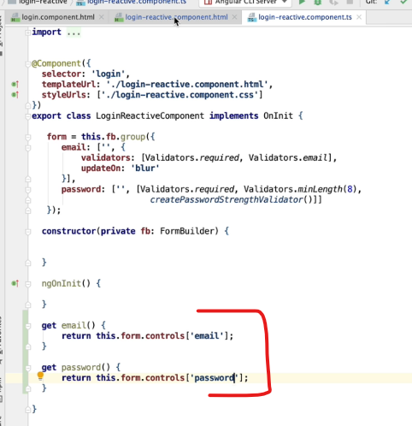

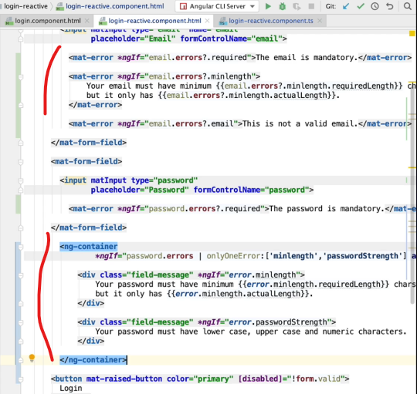

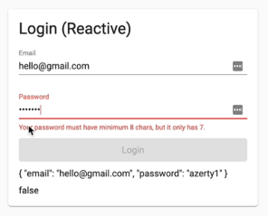

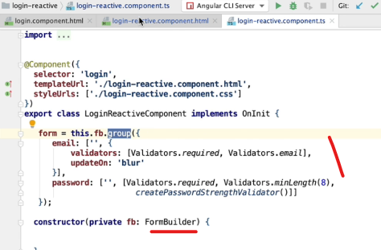

With the help of FormBuilder, now the code is very concise and very easy to look at what all validations are present for this form.

Also, it is extremely easy to add/remove validators as required.

## 27. Angular Strictly Typed Forms

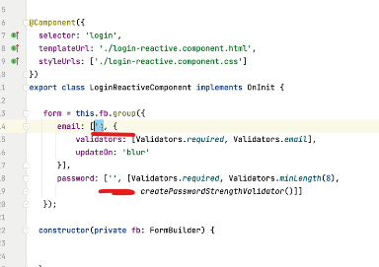

The type will be inferred from the initial value that we provide here.

Here the inferred type is String or null.

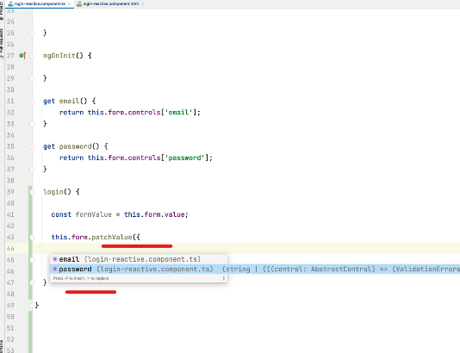

Even when we try to do a patchValue on it, it knows the declarations present in it.

Caution:

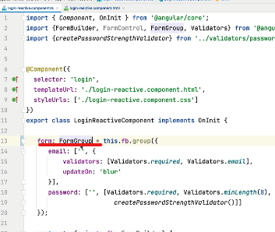

Do not do this type check on the LHS as it will by default become a FormGroup of type any and lose all the inference from the right hand side.

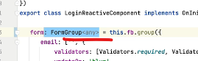

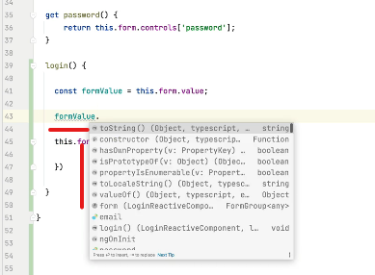

By this the auto-completion is also lost.

Reactive forms as now strongly typed.

## 28. Non Nullable Form Builder

Next, how to control the nullability property of each form field.

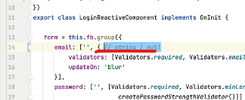

This can be String or null when we reset the form. But in some cases, if we need that this field should never be null. Then?

Union type in typescript: String | null

Let’s create a reset button to see this in action:

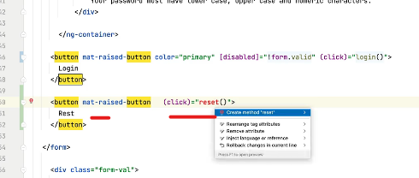

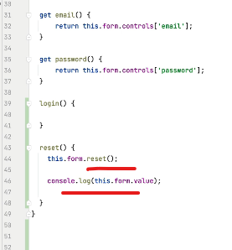

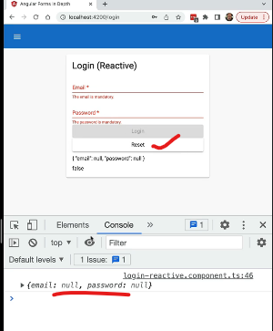

Note: Every single form field is considered as nullable by default.

For non nullable: use the nonNullable API

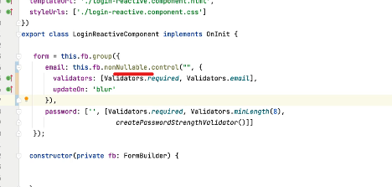

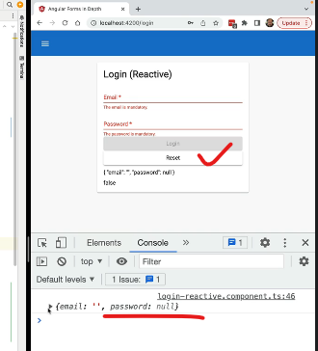

This is a little verbose way to do it.

Let’s see another way to do it.

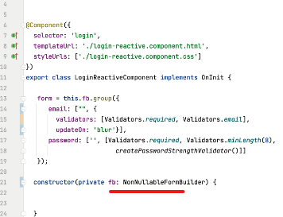

Use this instead of FormBuilder. Now all fields becomes non nullable by default.

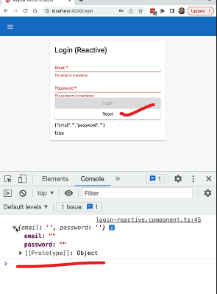

Thus, reactive forms have strong type safety now. We just have to set the initial value, and Angular will get the type of the field.

# Section 4: Angular Reactive Forms In Depth

## 29. New Section - Advanced Reactive Forms

Next our goal is to create much more complex multi-step reactive forms.

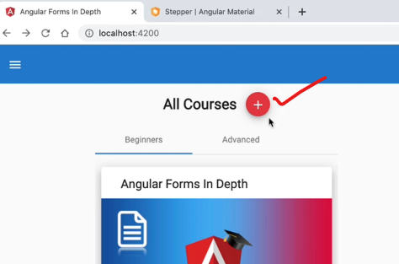

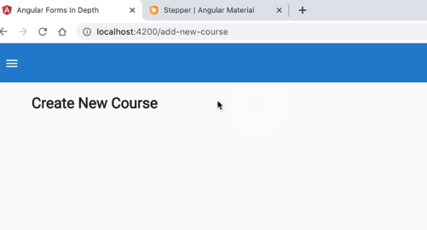

We will create “Create New Course form”.

The Stepper component:

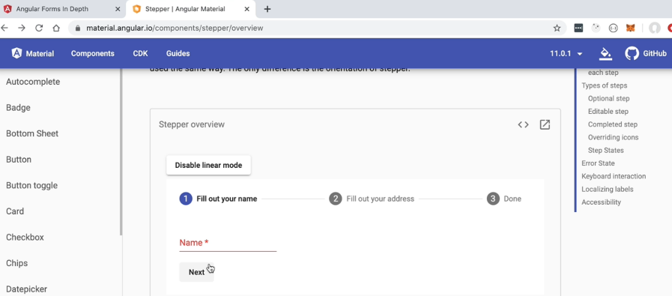

If we enable “linear mode”, then user will not be able to move to the next step without filling all the details in the current step.

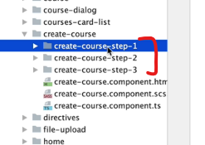

3 separate folders for the 3 steps.

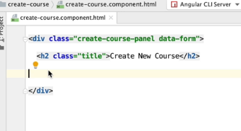

This is the top-level component for our form.

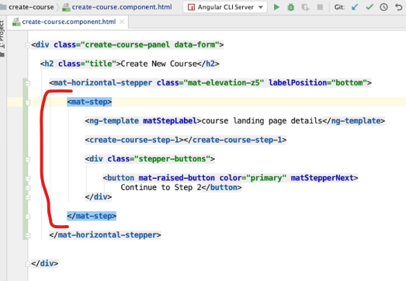

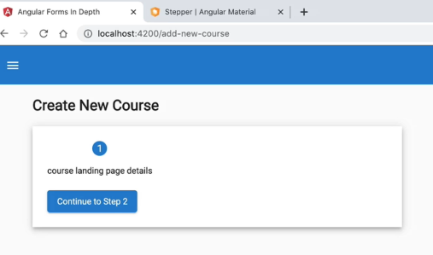

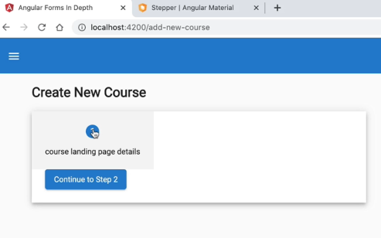

We will also see how to create composite nested forms.

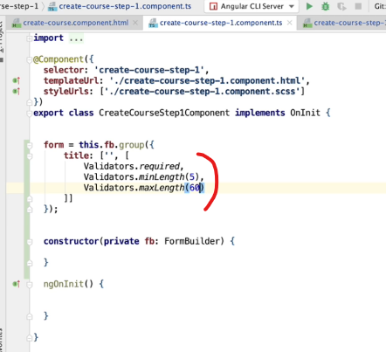

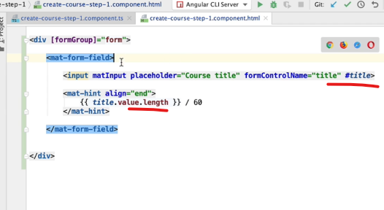

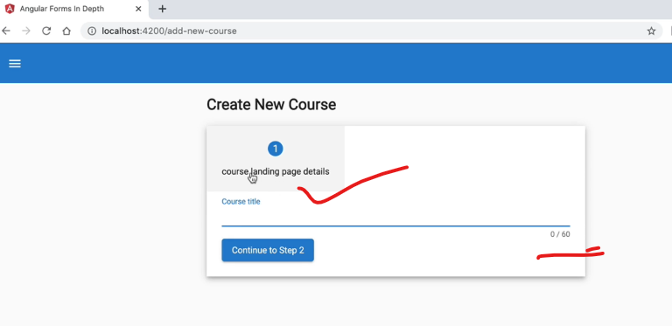

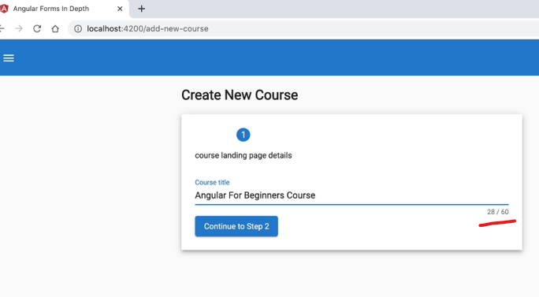

## 30. Building an Angular Multi-Step Reactive Form with Angular Material



All the validators we have seen so far are synchronous validators.

Now what if we have to do a backend call?

## 31. Angular Asynchronous Form Validators

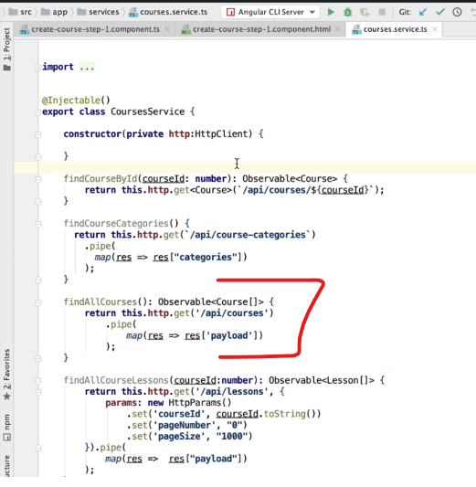

On blur of title, lets loop through this already present findAllCourses and check if our title is unique.

Let’s create a new validator for this:

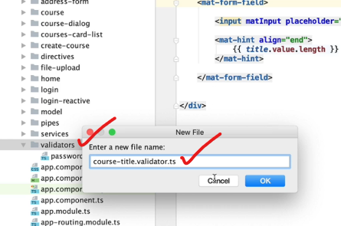

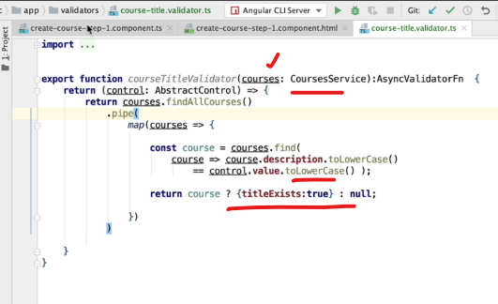

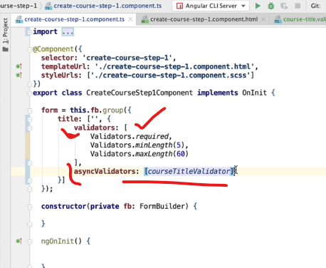

We would not want to call this asyncValidators every time the user types in, so lets use the updateOn:

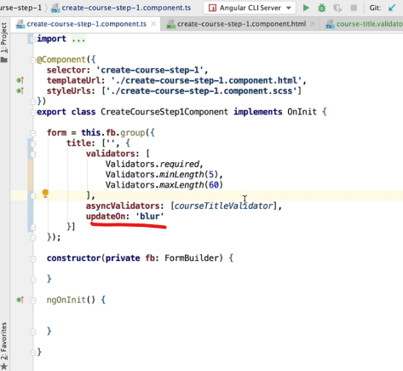

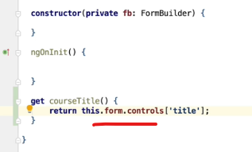

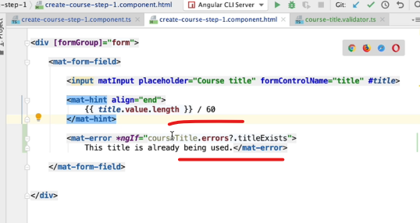

Pro: why cant we use here #title? why to create a separate getter?

We forgot this:

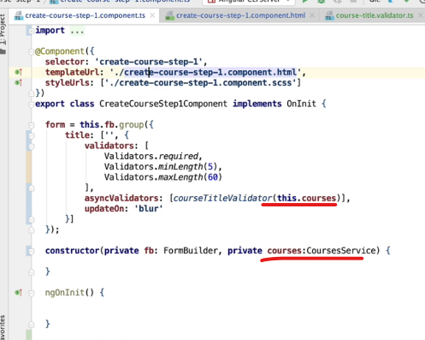

As we type, no backend calls are made:

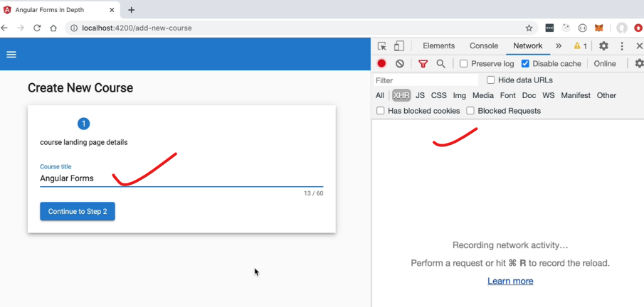

As soon as we blur the field, we get the same in the network tab:

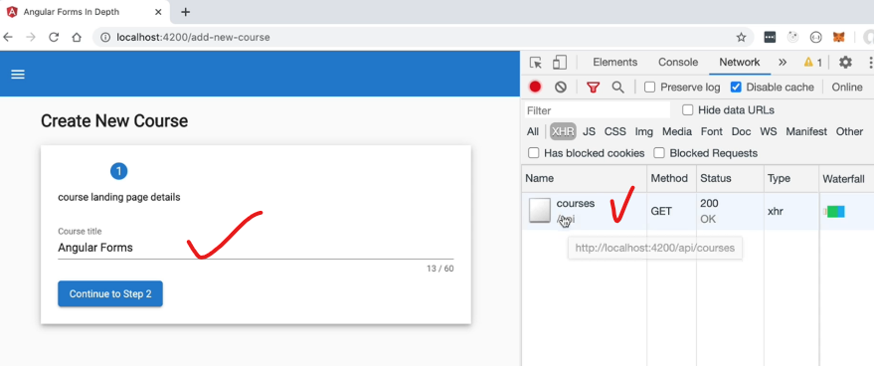

When we use an existing course title:

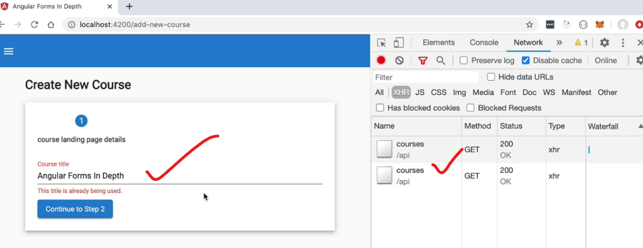

## 32. Angular Forms Controls - How to add a DatePicker field to a Reactive Form

Date picker:

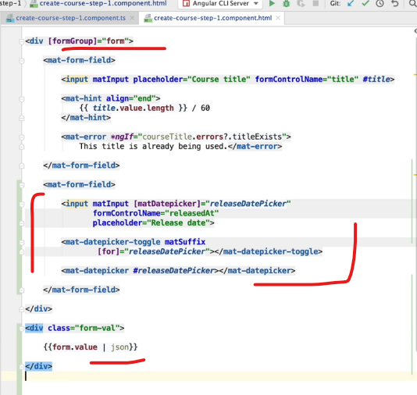

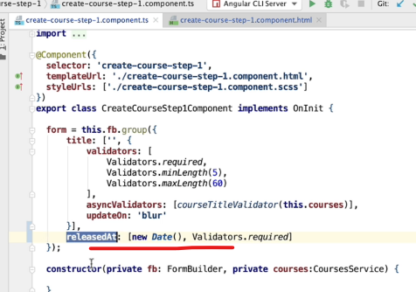

On page load:

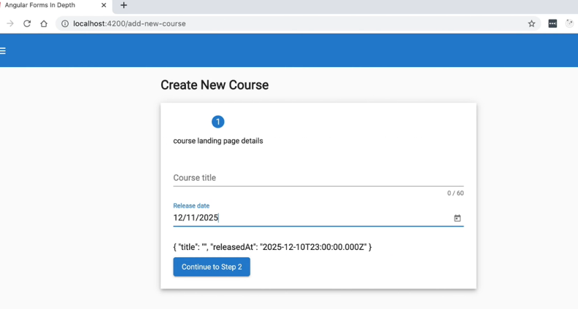

We can directly type the date or input it using the date picker:

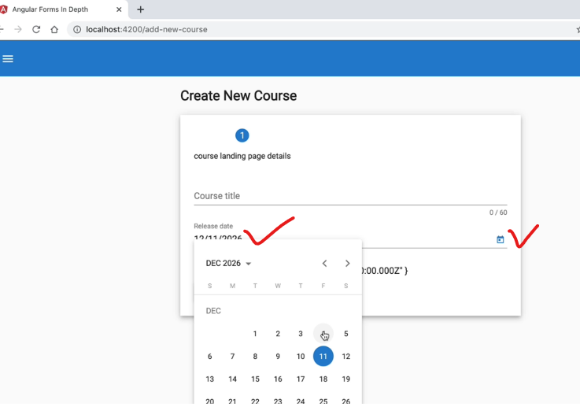

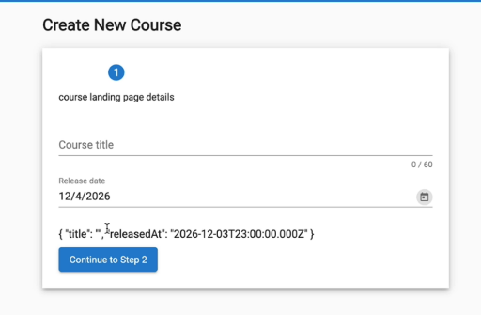

## 33. Angular Form Controls - Checkbox and Text Area

Checkbox:

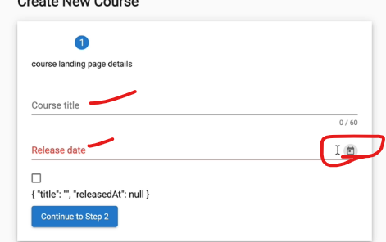

All these are part of the form field, which gives it a floating label kind of look and feel. But the same is not applicable for check box.

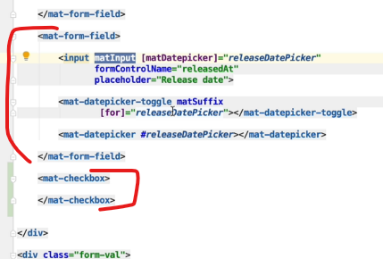

Mat-form-filed projects that content inside its template using Angular Content Projection.

But for checkbox that logic is not necessary. So, we don’t need a material form field.

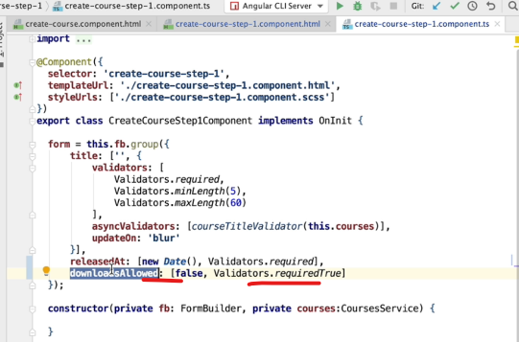

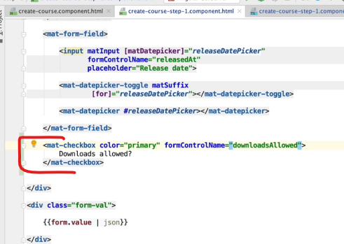

Next lets create a text area:

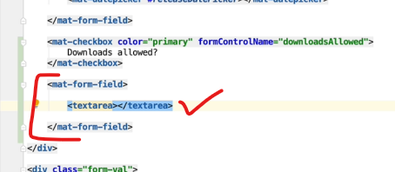

Textarea is not an angular component rather is a HTML component.

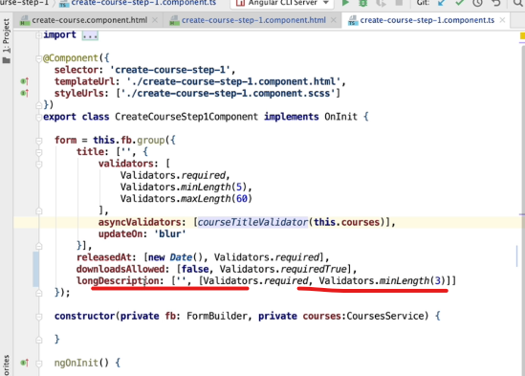

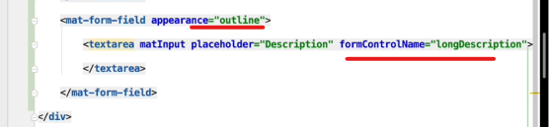

Next, we only want user to go to step 2, only if valid data is filled in step 1:

We set this with the “linear” set to true.

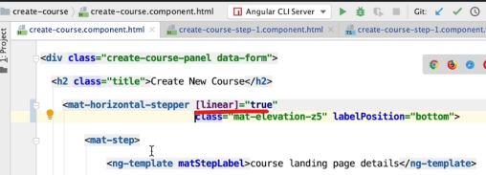

Next how do we know if all the valid data is filled or not?

We use “stepControl”

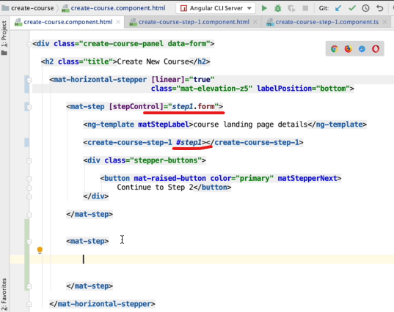

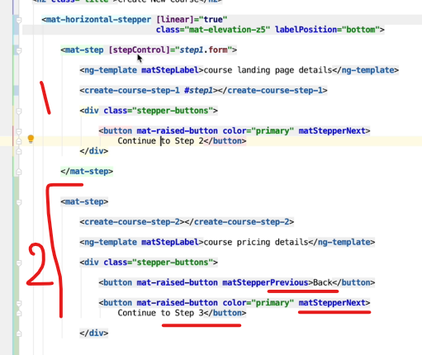

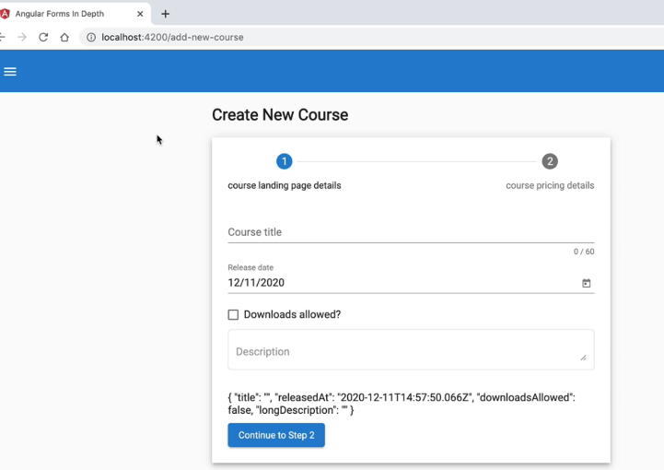

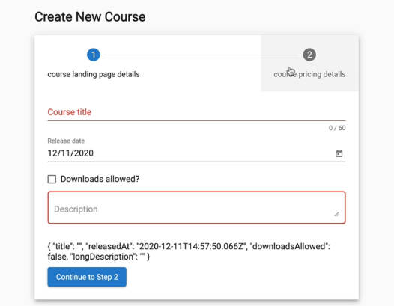

If we click on step 2, all the required fields gets highlighted in red in step 1.

The same will happen if we click on the button “Continue to Step 2”

After filling all the details:

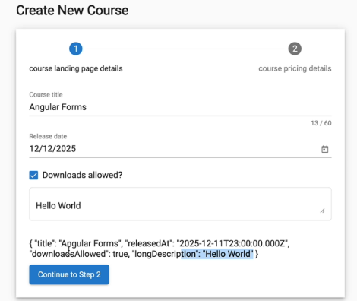

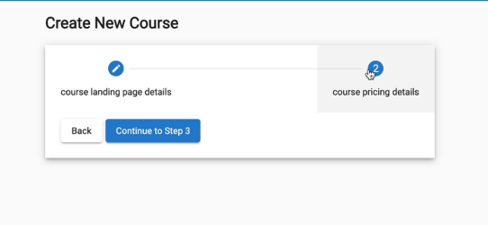

Now we can proceed to step 2

We can go back to the previous step with the “Back” button.

TO DO:

Multi field validations

Dynamically adding and removing form fields

Form arrays

Reusable nested FormGroups

Custom FormControls

Form Draft Pre-Save

File Upload

Custom File Upload FormControl

## 34. Angular Selection Dropdown Form Control - Step-by-Step Example

Selection dropdown with the data coming from the backend.

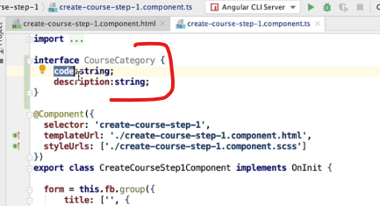

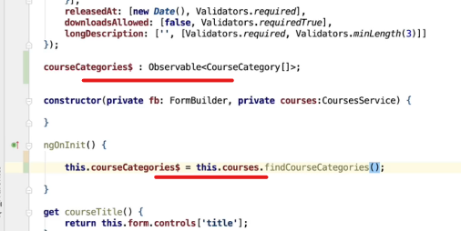

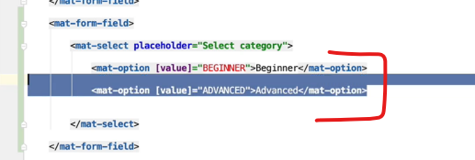

Hardcoded example, but as we have the backend call, we would not need this.

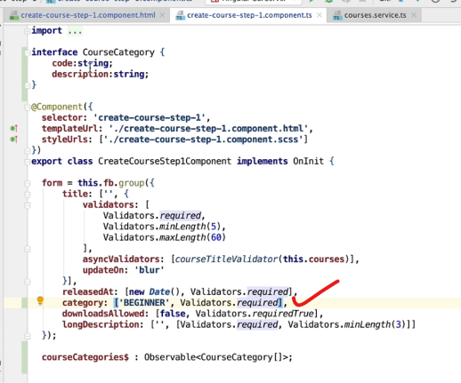

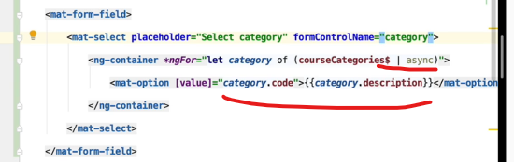

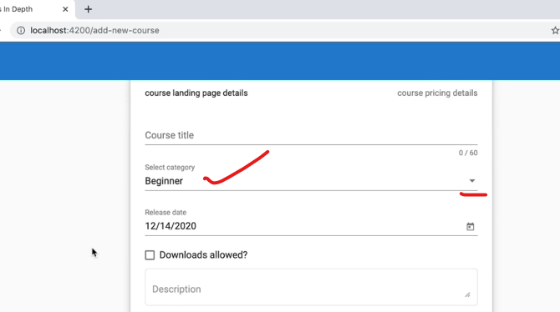

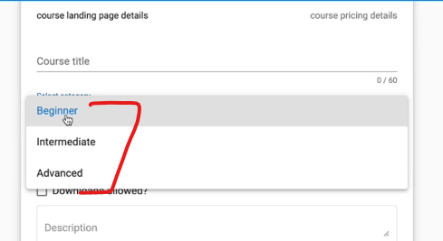

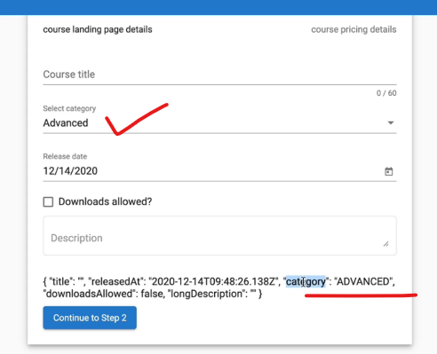

## 35. Multi-Step Forms - Displaying an Error Message per Step

Step 2 form:

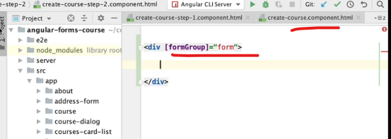

Each step will have their own form and their own validity states.

Radio buttons:

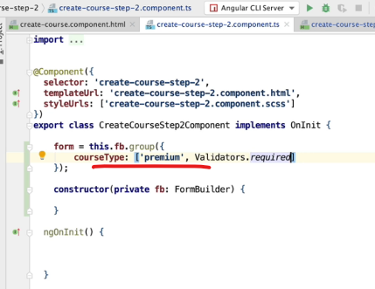

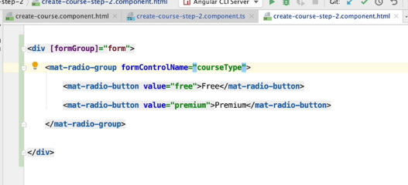

Lets set this to false temporarily:

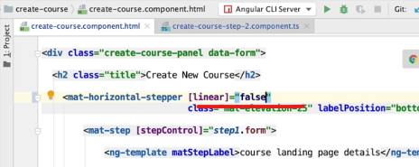

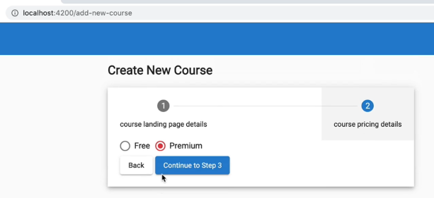

Next if user directly clicks on tab 2 without filling tab 1, we would want to show an error:

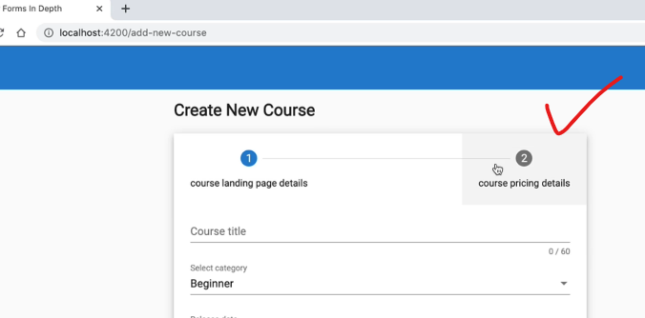

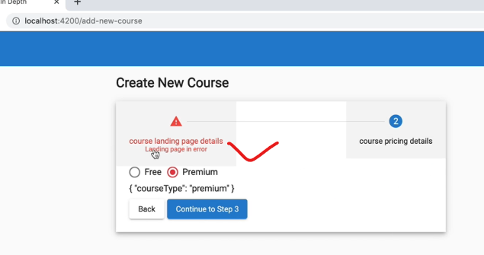

Enable the showError feature:

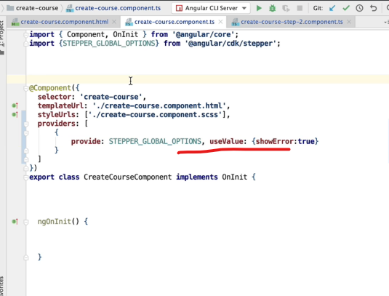

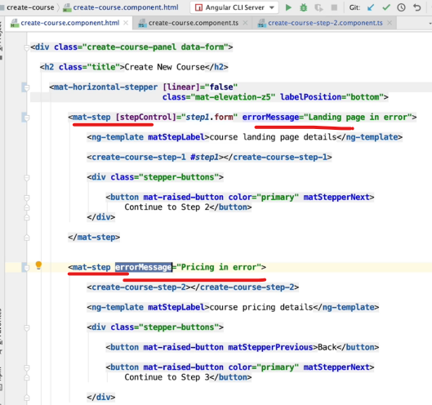

## 36. Reactive Forms - Dynamically Enabling and Disabling Form Fields

Numeric field:

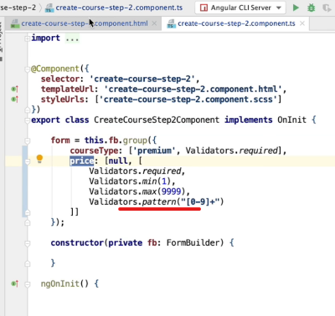

Use the regex to make it only numeric.

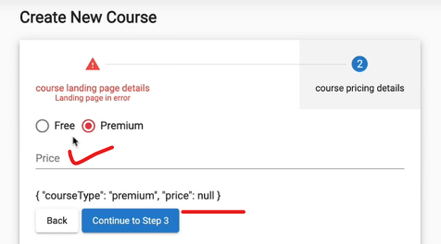

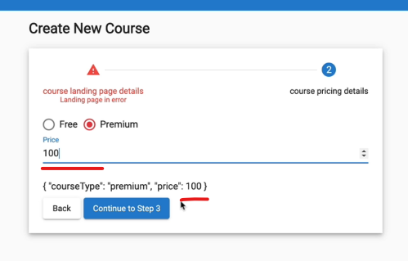

Only numbers will be allowed to enter here.

Pro: check by typing letters

Next lets only enable it for the Premium radio button.

For this we have to use the Observable valueChanges.

It does not matter whether the value is valid/invalid, any change win value will emit it.

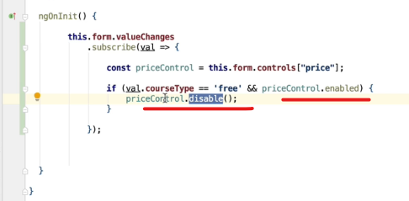

As the valueChanges will emit very frequently, we would only disable only if it is enabled. So, the check in the if condition.

Issue: once it is disabled, it will again emit this event, and this may go into an infinite loop. So we need to use emitEvent as false.

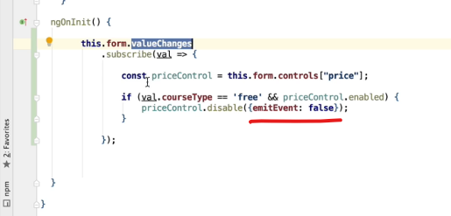

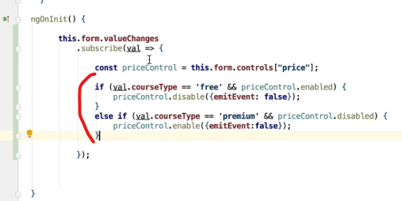

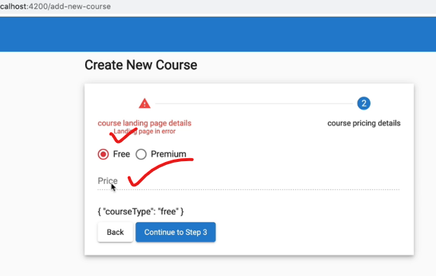

On click of “free”, the price field is disabled.

## 37. Angular Material Date Range Selector - Step-by-Step Example

Date range selector

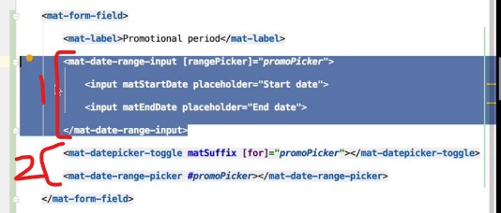

2: needs to be placed outside of <mat-date-range-input> and inside <mat-form-field>

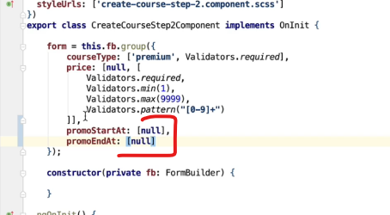

No validators as this is an optional field.

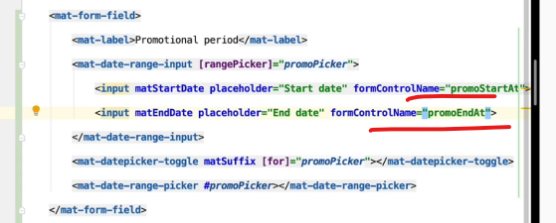

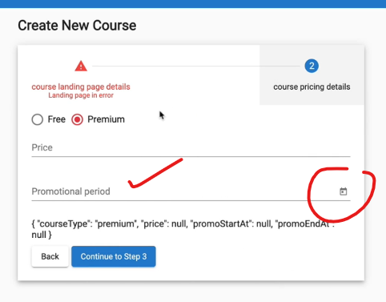

On page load.

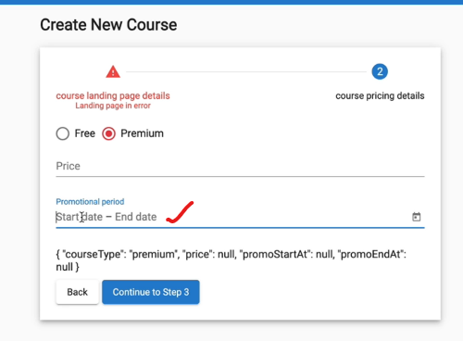

We can either type it manually:

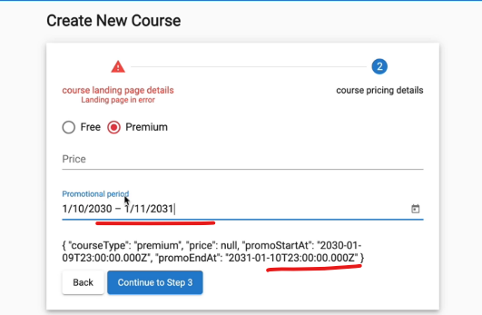

Or we can also use the toggle button:

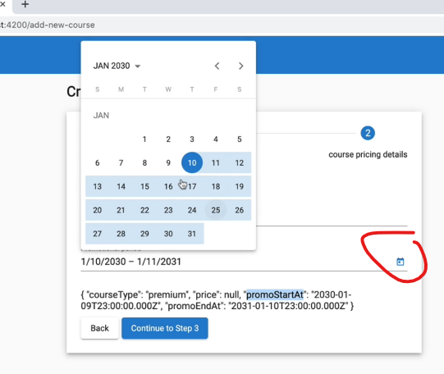

## 38. Reactive Forms Multi-field Custom Validation

In the above date range, from the date picker, Angular has prevent the user from selecting an invalid end date (i.e., date before the start date).

But if we type it manually then we can do it, so how do we prevent it?

## 39. How to implement Form Draft Pre-Save using the valueChanges Observable API

Aaaa

# Section 5: Angular Custom Form Controls

## 40. New Section - Angular Custom Form Controls - a File Upload Component

Aaaaa

## 41. Custom File Upload Component - Step-by-Step Implementation

Aaaa

## 42. Angular File Upload - Opening a File Upload Dialog

Aaaa

## 43. Angular File Upload - Uploading to a Node Server using the HTTP Client

Aaaa

## 44. Implementing a File Upload Progress Indicator

Aaaa

## 45. Understanding the Angular Forms ControlValueAccessor Interface

Aaaa

## 46. ControlValueAccessor Interface - Step-by-Step Implementation

Aaaa

## 47. ControlValueAccessor - Setting Up DI Configuration and Demo

Aaaa

## 48. Angular Custom Form Controls - The Validator Interface

Aaaa

## 49. What is a Reusable Nested Form?

Aaaa

## 50. How to Use ControlValueAccessor to implement a Nested Form

Aaaa

# Section 6: Form Arrays In Depth

## 51. New Section - Setting Up Step 3 of our Multi-step Form

Aaaa

## 52. Preparing Step 3 of our Multi-Step Form

Aaaaa

## 53. Angular Form Arrays - Step-by-Step Example

Aaaa

## 54. Angular Multi-Step Form - Final Demo

Aaaa

# Section 7: Conclusion

## 55. Bonus Lecture

Aaaa

## 56. Angular Forms In Depth - Conclusions & Key Takeaways

aaaa